### Client: German American Bank

**Project Name: 4977 Lanier Islands Pkwy**

**Keystone File #CM031124**

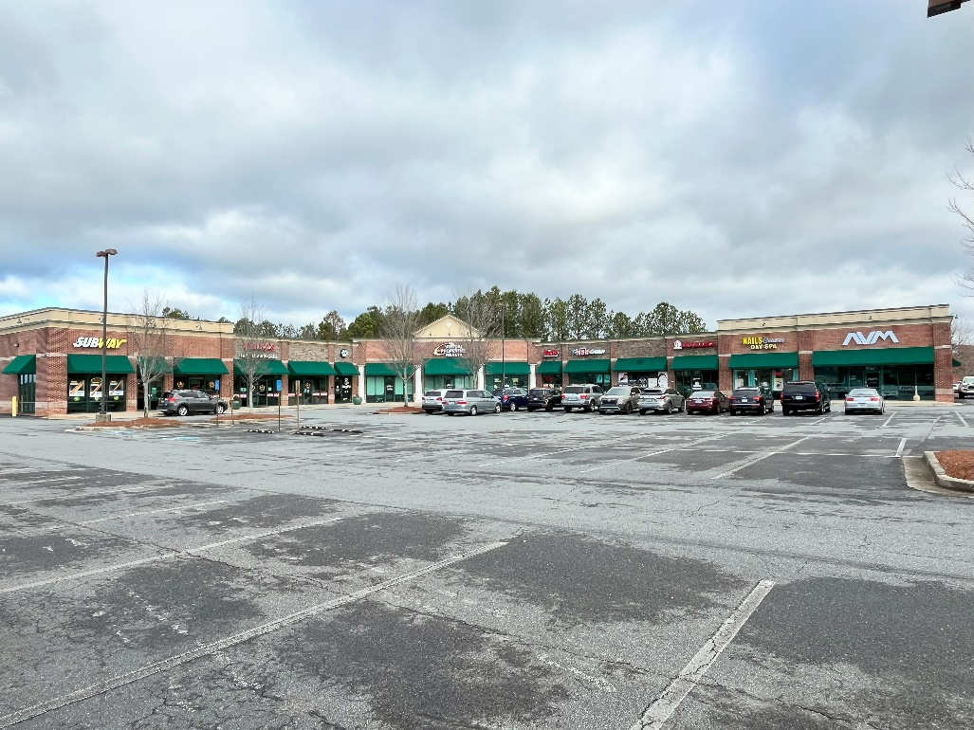

**23,450 Sq. Ft. Retail Building**

**On 2.44 Acres**

**4977 Lanier Islands Pkwy**

**Buford, Hall County**

**Georgia 30518**



March 4, 2024

German American Bank

c/o Drake Higdon, Loan Operations

P.O Box 810

Jasper, Indiana 47547

Keystone File: CM031124

To Whom it May Concern:

At your request, Keystone Valuations has prepared an appraisal for the above-referenced property, which may be briefly described as follows.

The subject property is located on the northwest corner of Lanier Islands Parkway and B U Bowman Drive within the City of Buford, in Hall County, GA. The subject property is improved with a one-story retail building which contains 23,450 rentable square feet and was built in 2001. As of the effective date, the property is estimated to be 88% leased to multiple tenants. The property is situated on one tax parcel which contains 2.44 acres. The subject is zoned C-2, General Business District within the City of Buford.

The Market Value(s) of the subject property is subject to the attached Basic Assumptions and Limiting Conditions, Extraordinary Assumptions and Hypothetical Conditions (if any). The appraisal is intended to conform with the Uniform Standards of Professional Appraisal Practice (USPAP), the Code of Professional Ethics and Standards of Professional Appraisal Practice of the Appraisal Institute, and applicable state appraisal regulations.

It is our opinion that the Market Value in the Leased Fee Estate, of the 23,450 sq. ft. Retail Building, *“As Is”* located at 4977 Lanier Islands Pkwy, Buford, Hall County, Georgia, as of February 23, 2024, is:

|  |
| --- |
| **FOUR MILLION SIX HUNDRED THOUSAND DOLLARS**  **($4,600,000)** |

The following report is a detailed summary of the pertinent data and analyses used in arriving at our conclusion.

It has been a pleasure to serve you in this matter.

Sincerely,

 

Rick A. Kenny, MAI, SRA Richard J. Kenny

Keystone Valuations LLC Keystone Valuations LLC

[rick@ keystonevaluations.com](mailto:rick@%20keystonevaluations.com%20)  [richard@keystonevaluations.com](mailto:richard@keystonevaluations.com)

770-823-4954



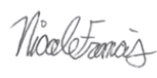

Blake P. Fine, MAI Nicole A. Francis

Keystone Valuations LLC Keystone Valuations LLC

[blake@keystonevaluations.com](mailto:blake@keystonevaluations.com) [nicole@keystonevaluations.com](mailto:nicole@keystonevaluations.com)

**BASIC ASSUMPTIONS AND LIMITING CONDITIONS**

This appraisal is subject to the following conditions:

1. This appraisal is for no purpose other than property valuation, and the appraiser(s) are neither qualified nor attempting to go beyond that narrow scope. The reader should be aware that there are also inherent limitations to the accuracy of the information and analyses contained in this appraisal. Before making any decision based on the information and analyses contained in this report, it is critically important to read this entire section to understand these limitations.

1. The legal description/survey furnished is assumed to be cor­rect. No responsibility is assumed for matters legal in character nor is any opinion rendered as to the title, which is assumed to be good and marketable. The value estimate is given without regard to any questions of title, boundaries, encumbrances, or encroachments.
2. All existing liens and encumbrances have been disregarded un­less otherwise stated, and the property is appraised as though free and clear under responsible ownership and compe­tent man­agement.
3. It is assumed that any proposed or incomplete improvements included in this re­port are to be completed in accordance with approved plans and specifications and in a workmanlike manner.
4. Information furnished by others is believed to be reliable, but no responsibility is assumed for its accuracy. Information (including projections of income and expenses) provided by local sources, such as government agencies, financial institutions, accountants, attorneys, and others is assumed to be true, correct, and reliable. No responsibility for the accuracy of such information is assumed by the appraiser(s).

The comparable sales data relied upon in the appraisal are believed to be from reliable sources. Though all the comparables were examined, it was not possible to inspect them all in detail. The value conclusions are subject to the accuracy of this data.

1. Any sketches, plats, or drawings included in this report are included to assist the reader in visualizing the property. We have made no survey of the property and assume no responsibility in connection with such matters. Any maps, plats, or drawings reproduced and included in this report are intended only for the purpose of showing spatial relationships. The reliability of the information contained on any such map or drawing is assumed by the appraiser(s) and cannot be guaranteed to be correct. A surveyor should be consulted if there is any concern on boundaries, setbacks, encroachments, or other survey matters.
2. Unless otherwise noted herein, it is assumed that there are no encroachments, zoning restrictions, or violations existing in the subject property. It is assumed that all applicable zoning and use regulations and restrictions have been complied with, unless nonconformity has been stated, defined, and considered in the appraisal report. Information and analysis shown in this report concerning these items is based only on a rudimentary investigation. Any significant question should be addressed to local zoning or land use officials and/or an attorney.
3. It is assumed that all required licenses, consents, or other legislative or administrative authority from any local, state, national government or private entity or organization have been, or can be obtained or renewed for any use on which the value estimate contained in this report is based. Appropriate government officials and/or an attorney should be consulted if an interested party has any questions or concerns on these items since we have not made a comprehensive examination of laws and regulations affecting the subject property.
4. We are not required to give testimony or attendance in court by reason of this appraisal, with reference to the property in question, unless arrangements have been made previously thereof.
5. No responsibility is assumed for engineering matters, either structural or mechanical. Good structural and mechanical conditions are assumed to exist, and no opinion as to these matters is to be inferred or construed from this re­port. Although the appraisal may contain information about the physical items being appraised (including their adequacy and/or condition), it should be clearly understood that this information is only to be used as a general guide for property valuation and not as a complete or detailed physical report. The appraiser(s) are not construction, engineering, environmental, or legal experts, and any statement given on these matters in this report should be considered preliminary in nature.
6. The observed condition of the foundation, roof, exterior walls, interior walls, floors, heating system, plumbing, insulation, electrical service, and all mechanical systems and construction is based on a casual inspection only and no detailed inspection was made. For instance, we are not experts on heating systems and no attempt was made to inspect the interior of the furnace. The structures were not checked for building code violations, and it is assumed that all buildings meet applicable building codes unless stated in the report.

Some items such as conditions behind walls, above ceilings, behind locked doors, or under the ground are not exposed to casual view and therefore were not inspected. The existence of insulation, if any is mentioned, was found by conversation with others and/or circumstantial evidence. Since it is not exposed to view, the accuracy of any statements about insulation cannot be guaranteed.

It is assumed that there are no hidden or unapparent conditions of the property, sub‑soil, or structures that would render it more or less valuable. No responsibility is assumed for such conditions, or for the engineering that may be required to discover such factors. Since no engineering or percolation tests were made, no liability is assumed for soil conditions. Sub‑surface rights (mineral and oil) were not considered in making this appraisal. Wells and septic systems, if any, are assumed to be in good working condition and of sufficient size and capacity for the stated highest and best use.

1. Because no detailed inspection was made, and because such knowledge goes beyond the scope of this appraisal, any observed condition or other comments given in this appraisal report should not be taken as a guarantee that a problem does not exist. Specifically, no guarantee is made as to the adequacy or condition of the foundation, roof, exterior walls, interior walls, floors, heating system, air conditioning system, plumbing, electrical service, insulation, or any other detailed construction matters. If any interested party is concerned about the existence, condition, or adequacy of any particular item, it is strongly suggested that a construction expert be hired for a detailed investigation.
2. Disclosure of the contents of this appraisal report is governed by the Bylaws and Regulations of the Appraisal Institute.

One (or more) of the signatories of this appraisal report is a Member (or Candidate Member) of the Appraisal Institute. The By­laws and Regulations of the Appraisal Institute require each Member and Candidate Member to control the use and distribution of each apprais­al report signed by such Member or Candidate Member. There­fore, except as hereinafter provided, the party for whom this appraisal report was prepared may distribute copies of this appraisal report, in its entirety, to such third parties as may be se­lec­ted by the party for whom this appraisal report was pre­pared; however, selected portions of this appraisal report shall not be given to third parties without the prior written consent of the signatories of this appraisal report. Further, neither all nor any part of this appraisal report shall be dissem­inated to the general public by the use of advertising media or other media for public communication without the prior written consent of the signatories of this appraisal report.

1. The value estimate applies only to the entire property and cannot be prorated to individual portions or fractional interests. Any proration or division of interest will invalidate the value estimate, unless such proration or division of interests is set forth in the report.

The forecasts or projections included in this report are util­ized to assist in the valuation process. They are based on current market conditions, current short-term supply and demand factors, and a continued stable economy. These forecasts are therefore subject to changes in future conditions which cannot be accurately predicted by the appraiser(s), and these changes could affect the future income and/or value estimates. Since projected mathematical models and other projections are based on estimates and assumptions which are inherently subject to uncertainty and variation depending upon evolving events, we do not represent them as results that will actually be achieved.

1. In this appraisal assignment the existence of potentially ha­zardous material such as asbestos, urea formaldehyde foam insulation, radon gas, or any other toxic material, has not been considered. The appraiser(s) are not qualified to detect such substances and, if desired, recommend that the client retain an expert in this field.

Non-disclosure of environmental problems should not be taken as an indication that such a problem does not exist, however an expert in the field should be consulted if any interested party has questions on environmental factors. No chemical or scientific tests were performed by the appraiser(s) on the subject property, and it is assumed that the air, water, ground, and general environment associated with the property presents no physical or health hazard of any kind unless otherwise noted in the report. It is further assumed that the lot does not contain any type of dump site and that there are no underground tanks (or any underground source) leaking toxic or hazardous chemicals into the groundwater or the environment unless otherwise noted in the report.

1. It is assumed that there is full compliance with all applicable federal, state, and local environmental regulations unless noncompliance is stated, defined, and considered in the appraisal report. A comprehensive examination of laws and regulations affecting the subject property was not performed for this appraisal.
2. The subject property may or may not be located in or adjacent to a wetlands area. The appraiser(s) are not qualified in the area of engineering pertaining to the determination of wetlands; therefore, the appraiser(s) are unable to determine the wetlands status of the subject property. In this report, it is assumed the appropriate permit, if required, can be or has been obtained from the U.S. Army Corps of Engineers. It is also assumed that the jurisdictional determination study and/or permit regarding construction in a wetlands area, if required, does not result in the alteration of the subject property description contained in this appraisal report. The appraiser(s) recommend that a pre-application consultation be completed by the property owner with the Corps of Engineers if no permit has been obtained. The client is urged to retain an expert in this field, if desired.
3. The Americans with Disabilities Act (ADA) became effective January 26, 1992. We have not made a specific compliance survey and analysis of this property to determine whether or not it is in conformity with the various detailed requirements of the ADA. It is possible that a compliance survey of the property together with a detailed analysis of the requirements of the ADA could reveal that the property is not in compliance with one or more of the requirements of the act. If so, this fact could have a negative effect upon the value of the property. Since we have no direct evidence relating to this issue, we did not consider possible noncompliance with the requirements of ADA in estimating the value of the property.
4. Opinions and estimates expressed herein represent our best judgment but should not be construed as advice or recommendation to act. Any actions taken by you, the client, or any others should be based on your own judgment, and the decision process should consider many factors other than just the value estimate and information given in this report.
5. The appraiser has not identified any purchaser, borrower, or seller as an intended user of this appraisal and no such party should use or rely on this appraisal for any purpose. Such parties are advised to obtain an appraisal from an appraiser of their choosing if they require an appraisal for their own use. This appraisal report should not serve as the basis for any property purchase decision or any appraisal contingency in a purchase agreement relating to the property.
6. Any reproduction, copy, graphical representation, or analysis of the contents of this report is expressly forbidden without express written consent from Keystone Valuations LLC and/or the parties signing the certification of this report.

# EXTRAORDINARY ASSUMPTIONS AND HYPOTHETICAL CONDITIONS

**Extraordinary Assumptions**

None

**Hypothetical Conditions**

None

**CERTIFICATION**

We certify that, to the best of my knowledge and belief:

− The statements of fact contained in this report are true and correct.

− The reported analyses, opinions, and conclusions are limited only by the reported assumptions and limiting conditions and is our personal, impartial, and unbiased professional analyses, opinions, and conclusions.

− I have no present or prospective interest in the property that is the subject of this report and no personal interest with respect to the parties involved.

− I have performed no services, as an appraiser or in any other capacity regarding the property that is the subject of this report within the three-year period immediately preceding acceptance of this assignment.

− I have no bias with respect to the property that is the subject of this report or to the parties involved with this assignment.

− My engagement in this assignment was not contingent upon developing or reporting predetermined results.

− My compensation for completing this assignment is not contingent upon the development or reporting of a predetermined value or direction in value that favors the cause of the client, the amount of the value opinion, the attainment of a stipulated result, or the occurrence of a subsequent event directly related to the intended use of this appraisal.

− My compensation is not contingent upon the reporting of a predetermined Fair Market Value or direction in Fair Market Value that favors the cause of the client, the amount of the Fair Market Value estimate, the attainment of a stipulated result, or the occurrence of a subsequent event. Further, my fee has not been based in whole or in part upon a percentage of the appraised Fair Market Value of the property, nor has the fee in any way been contingent upon the appraised Fair Market Value.

− My analyses, opinions, and conclusions were developed, and this report has been prepared, in conformity with the *Uniform Standards of Professional Appraisal Practice* *and in conformity with the Georgia Real Estate Appraisers Classification and Regulations Act, and the Rules and Regulations of the Georgia Real Estate Appraisers Board.*

− The use of this report is subject to the requirements of the Appraisal Institute relating to review by its duly authorized representatives.

− There has been no exclusion of items pertinent to the assignment, nor exclusion of items beyond this assignment.

− Nicole A. Francis, State Certified General, **has** made a personal inspection of the property that is the subject of this report. Rick Kenny, MAI, SRA, Richard Kenny, Candidate for Designation, Blake P. Fine, MAI, **have not** made a personal inspection of the property that is the subject of this report.

− No one else has provided real property appraisal assistance to the undersigned.

− The reported analyses, opinions, and conclusions were developed, and this report has been prepared, in conformity with the Code of Professional Ethics and Standards of Professional Appraisal Practice of the Appraisal Institute.

− The use of this report is subject to the requirements of the Appraisal Institute relating to review by its duly authorized representatives.

− As of the date of this report, Rick Kenny, MAI, SRA and Blake P. Fine, MAI **have** completed the continuing education program for Designated Members of the Appraisal Institute. Richard Kenny, Candidate for Designation, **has** completed the Standards and Ethics Education Requirements for Candidate for Designation of the Appraisal Institute.



Rick A. Kenny, MAI, SRA Richard J. Kenny

State Certified Appraiser State Certified Appraiser

Certified General #628 Certified General #373297

AI#66318

 

Blake P. Fine, MAI Nicole A. Francis

State Certified Appraiser State Certified Appraiser

Number #260129 Number #417210

**EXECUTIVE SUMMARY**





**VALUE INDICATIONS**



Subject Photographs

|  |  |  |
| --- | --- | --- |
|  |  |  |
| Subject Front Exterior  (Photo Taken on February 23, 2024) |  | Subject Signage Exterior  (Photo Taken on February 23, 2024) |
|  |  |  |
| |  |  |  | | --- | --- | --- | | Rear to Side Exterior  (Photo Taken on February 23, 2024) |  | Subject Signage Exterior  (Photo Taken on February 23, 2024) |  |  | Side Exterior  (Photo Taken on February 23, 2024)   |
| Address Verification  (Photo Taken on February 23, 2024) |  | Side Exterior  (Photo Taken on February 23, 2024) |
| Subject Photographs   |  |  |
| Rear Exterior  (Photo Taken on February 23, 2024) |  | Lanier Islands Pkwy Looking West  (Photo Taken on February 23, 2024) |

|  |  |  |
| --- | --- | --- |
|  |  |  |
| Lanier Islands Pkwy Looking East  (Photo Taken on February 23, 2024) |  | B U Bowman Drive Looking North  (Photo Taken on February 23, 2024) |
|  |  |  |
| B U Bowman Drive Looking South  (Photo Taken on February 23, 2024) |  | B U Bowman Drive Curb Cut  (Photo Taken on February 23, 2024) |

Subject Photographs

|  |  |  |
| --- | --- | --- |
|  |  |  |
| Unit 101 - Subway  (Photo Taken on February 23, 2024) |  | Unit 102-103 – Vinny’s NY Pizza and Grill  (Photo Taken on February 23, 2024) |
|  |  |  |
| |  |  |  | | --- | --- | --- | | Unit 104 - Surgipet  (Photo Taken on February 23, 2024) |  | Subject Signage Exterior  (Photo Taken on February 23, 2024) |  |  | Unit 104 - Surgipet  (Photo Taken on February 23, 2024)   |
| Unit 105-106 – Virtual Properties Realty  (Photo Taken on February 23, 2024) |  | Unit 105-106 – Virtual Properties Realty  (Photo Taken on February 23, 2024) |
| Subject Photographs   |  |  |
| Unit 107 - Vacant  (Photo Taken on February 23, 2024) |  | Unit 107 - Vacant  (Photo Taken on February 23, 2024) |

|  |  |  |
| --- | --- | --- |
|  |  |  |
| Unit 111– Childers Family Insurance  (Photo Taken on February 23, 2024) |  | Unit 112 – Nail Salon Interior  (Photo Taken on February 23, 2024) |
|  |  |  |

**PURPOSE AND DATE OF APPRAISAL**

The purpose of this appraisal is to estimate the Market Value in Leased Fee Estate *“As Is”,* of the 23,450 sq. ft. Retail Building located at 4977 Lanier Islands Pkwy, Buford, Hall County, Georgia. The date of appraisal *“As Is”* is February 23, 2024.

# CLIENT, INTENDED USERS AND INTENDED USE OF APPRAISAL

This report is intended for use only by German American Bank and/or their affiliates. Use of this report by others is not intended by the appraisers. This report is intended only for loan underwriting and/or credit decisions. This report is not intended for any other use.

**APPRAISER COMPETENCY**

Rick Kenny, MAI, SRA and Certified General Appraiser in Georgia, Blake P. Fine, MAI, and Certified General Appraiser in Georgia, Richard Kenny, Certified General Appraiser in Georgia, and Nicole A. Francis Certified General Appraiser in Georgia, have appraised multiple retail facilities. Therefore, we have met the requirements of the USPAP Competency Rule.

**TYPE OF REPORT**

According to the Uniform Standards of Professional Appraisal Practice (USPAP), Standards Rule 2-2, an appraisal report must be prepared under one of the following options and prominently state which option is used: Appraisal Report or Restricted Appraisal Report. These report types are described as follows:

* Appraisal Report: The content must be consistent with the intended use of the appraisal and, at minimum: (i) state the identity of the client and any intended users, by name or type; (ii) state the intended use of the appraisal; (iii) summarize information sufficient to identify the real estate involved in the appraisal, including the physical, legal, and economic property characteristics relevant to the assignment; (iv) state the real property interest to be appraised; (v) state the type and definition of value and cite the source of the definition; (vi) state the effective date of appraisal and the date of the report; (vii) summarize the scope of work used to develop the appraisal; (viii) summarize the information analyzed, the appraisal methods and techniques employed, and reasoning that supports the analysis, opinions, and conclusions; exclusion of the Sales Comparison Approach, Cost Approach, or Income Approach must be explained; (ix) state the use of the real estate existing as of the date of value and the use of the real estate reflected in the appraisal; (x) when an opinion of highest and best use was developed by the appraiser, summarize the support and rational for that opinion; (xi) clearly and conspicuously: (1) state all extraordinary assumptions and hypothetical conditions; (2) and state that there use might have affected the assignment results; (xii) include a signed certification in accordance with Standards Rule 2-3.

* Restricted Appraisal Report: The content must be consistent with the intended use of the appraisal and, at minimum: (i) state the identity of the client, by name or type, and state a prominent use restriction that limits the use of the report to the client and warns that the rational for how the appraiser arrived at the opinions and conclusions set forth in the report may not be understood property without additional information in the appraiser’s work file; (ii) state the intended use of the appraisal; (iii) state information sufficient to identify the real estate involved in the appraisal; (iv) state the real property interest appraised; (v) state the type of value and cite the source of the definition; (vi) state the effective date of appraisal and the date of the report; (vii) state the scope of work used to develop the appraisal; (viii) state the appraisal methods and techniques employed, state the value opinion(s) and conclusion(s) reached, and reference the work file; exclusion of the Sales Comparison Approach, Cost Approach, or Income Approach must be explained; (ix) state the use of the real estate existing as of the date of value and the use of the real estate reflected in the appraisal; (x) when an opinion of highest and best use was developed by the appraiser, state the opinion; (xi) clearly and conspicuously: (1) state all extraordinary assumptions and hypothetical conditions; (2) and state that there use might have affected the assignment results; (xii) include a signed certification in accordance with Standards Rule 2-3.
* The Appraisal Report to be provided is to be labeled as a *Descriptive, Summary, or Restricted Report*. The Appraisal Report must also conform to any State mandated Supplemental Standards. Narrative reports should follow the format outlined in the most recent edition of the Appraisal of Real Estate published by the Appraisal Institute.
  + A *Descriptive* report is one that fully describes the information analyzed, the appraisal methods and techniques employed, and the reasoning that supports the analyses, opinions, and conclusions.
  + A *Summary* report is one that summarizes the information analyzed, the appraisal methods and techniques employed, and the reasoning that supports the analyses, opinions and conclusions.
  + A *Restricted* report is one that states the information analyzed, the appraisal methods and techniques employed, and the reasoning that supports the analyses, opinions, and conclusions.

This report is prepared as an **Appraisal Report**.

**PROPERTY RIGHTS APPRAISED**

One or more of the following underlined legal estates or interests are valued in this report. Definitions of these estates are quoted from *The Dictionary of Real Estate Appraisal*, Sixth Edition; published by the Appraisal Institute, copyright 2015.

* Fee Simple Estate *"Absolute ownership unencumbered by any other interest or estate, subject only to the limitations imposed by the governmental powers of taxation, eminent domain, police power, and escheat."*
* Leased Fee Estate *A freehold (ownership interest) where the possessory interest has been granted to another party by creation of a contractual landlord-tenant relationship."*
* Leasehold Estate *"The tenant's possessory interest created by a lease."*

The opinion of value developed in this report relates to the **Leased Fee Estate** of the subject property.

**VALUE OPINION**

Opinions of value are typically developed on the basis of one or more of the following dates or situations.

* Market Value "As Is" on the Appraisal Date: Market Value "As Is" on the appraisal date is an opinion of the market value of a property in the condition observed upon inspection and as it physically and legally exists without hypothetical conditions, assumptions, or qualifications as of the date the appraisal is prepared.
* Prospective Market Value "Upon Completion" of Renovation: Prospective market value "upon completion" of renovation is the future value of a property on the date that construction, conversion, or rehabilitation is completed, based upon market conditions forecast to exist as of that completion date.
* Prospective Market Value "Upon Reaching Stabilized Occupancy": Prospective market value "upon reaching stabilized occupancy" is the future value of a property when all improvements have been physically constructed and the property has been leased to its optimum level of long-term occupancy at the market rent level.

The value opinion for the subject property has been reported on the basis of **Market Value "As Is".**

# DEFINITION OF VALUE

**Market Value**

The following definition of *market value* was taken from Title XI of the Financial Institutions Reform, Recovery, and Enforcement Act (FIRREA) of 1989. *(Source: 12 C.F.R. Part 34.42(g); 55 Federal Register 34696, August 24, 1990, as amended at 57 Federal Register 12202, April 9, 1992; 59 Federal Register 29499, June 7, 1994.)*

Federal agencies publishing this definition include the

* Office of the Comptroller of the Currency (OCC) 12 CFR 34, subpart C
* Federal Reserve Board (FRB) 12 CFR 225, Subpart G
* Federal Deposit Insurance Corporation (FDIC) 12 CFR 323
* National Credit Union Administration (NCUA) 12 CFR 722

This definition, published jointly by the OCC, FRS, and FDIC, is referenced in Appendix D of the “*Interagency Appraisal and Evaluation Guidelines”* dated December 2, 2010*.* A very similar definition is also cited in Advisory Opinion 30 of the 2015-2016 version of the Uniform Standards of Professional Appraisal Practice (USPAP), lines 177 to 181.

*“****Market value*** *means the most probable price which a property should bring in a competitive and open market under all conditions requisite to a fair sale, the buyer and seller each acting prudently and knowledgeably, and assuming the price is not affected by undue stimulus. Implicit in this definition is the consummation of a sale as of a specified date and the passing of title from seller to buyer under conditions whereby:*

1. *buyer and seller are both typically motivated;*
2. *both parties are well informed or well advised and acting in what they consider their own best interests;*
3. *a reasonable time is allowed for exposure in the open market;*
4. *payment is made in terms of cash in U.S. dollars or in terms of financial arrangements comparable thereto; and*
5. *the price represents the normal consideration for the property sold unaffected by special or creative financing or sales concessions granted by anyone associated with the sale."*

This definition is used by many well-known entities. FDIC, Fannie Mae, Freddie Mac, the VA, and the FHA, which are governmental agencies or governmentally sponsored agencies, require usage of this definition as well.

**LEGAL DESCRIPTION**

A narrative metes and bounds legal description is available. Furthermore, the exhibits and descriptions included in this report help to adequately identify and describe the real estate being appraised. This is in compliance with the requirements of the Uniform Standards of Professional Appraisal Practice (USPAP), as adopted and published by the Appraisal Standards Board of The Appraisal Foundation. The applicable requirements are stated in Standards Rule 2-2 (b) (i) which states that “the appraisal report must identify and describe the real estate being appraised.” USPAP comments on this requirement as follows:

“Identifying the physical real estate can be accomplished by any combination of a legal description, address, map reference, copy of a survey or map, property sketch and/or photographs.”

The subject’s Legal Description can be found below.

All of that tract or parcel of land located in 1st District, 8th Section, Land Lot 157, Hall County, Georgia.

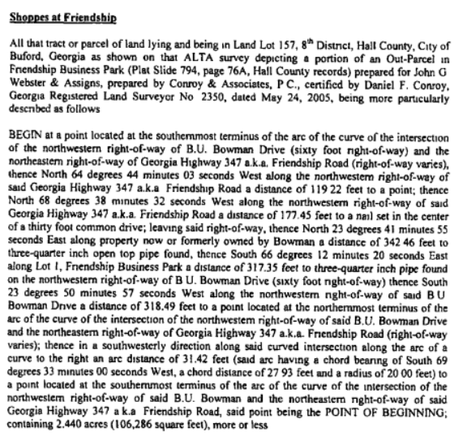

# SCOPE OF WORK

The 2023-2024 *Uniform Standards of Professional Appraisal Practice* establishes the “Scope of Work Rule” to guide the process of developing assignment results. Scope of Work is simply the work undertaken in developing the assignment and defined as “the type and extent of research and analyses in an appraisal or appraisal review assignment.” The focus of the scope of work rule is on ensuring that work undertaken is sufficient to develop credible assignment results. Scope of Work is simply the work undertaken in developing the assignment and defined as “the type and extent of research and analyses in an assignment.” The focus of the scope of work rule is on ensuring that work undertaken is sufficient to develop credible assignment results.

An appraisal is generally defined as an opinion of value based on the parameters of the assignment as of a specified date. The valuation of real estate is based on a process of data collection, analysis, and conclusions by a nonbiased third party. The purpose and date of this appraisal, along with the property rights appraised, have been previously defined. Information relating to the subject property also collected includes ad valorem tax data, zoning information, utility availability, floodplain information, topography, frontage, access, and existing improvements. Building plans are reviewed (if applicable) and the site plan studied as to the relationship of the site and the improvements. The improvements are inspected to determine the physical condition and functional utility. Other properties in the neighborhood are inspected to develop an overall opinion of the character, composition, and future trends of the submarket.

**Types of Market Data Researched**

Sales and leases with similar locations, physical traits, zoning, and highest and best use characteristics were analyzed and compared to the subject property where applicable. The appraisers took sufficient steps, common in the industry, to ensure the market data presented in this report are deemed accurate and reliable. The appraisers have made every attempt to confirm and authenticate any expert provided information, however, unless the appraisers found significant information to the contrary, expert provided information is deemed reliable and accurate. Market data included in this report was verified through multiple sources such as, public records of deeds and easements, subscription data sources, including CoStar among others, and interviews with brokers and/or grantors and grantees. Based on the credentials of the experts and the appraisers’ attempt to verify the information, there is no reason at this time to suspect that the provided information is not credible.

**Conclusion**

The scope of this appraisal does not include professional services outside the expertise of the appraiser. These professional services include, but are not limited to, the following: (1) deed restrictions, land use covenants, or other limitations on the property rights that may be revealed by an abstract or title insurance policy; (2) easements, encroachments, or other limitations of the title that may be revealed by a survey; (3) legal matters that require specialized knowledge beyond that ordinarily employed by a real estate appraiser; (4) information typically disclosed by an engineering study or environmental survey; (5) other services covered by the Basic Assumptions and Limiting Conditions set forth in this report.

**ATLANTA REGIONAL AND MARKET AREA DATA**

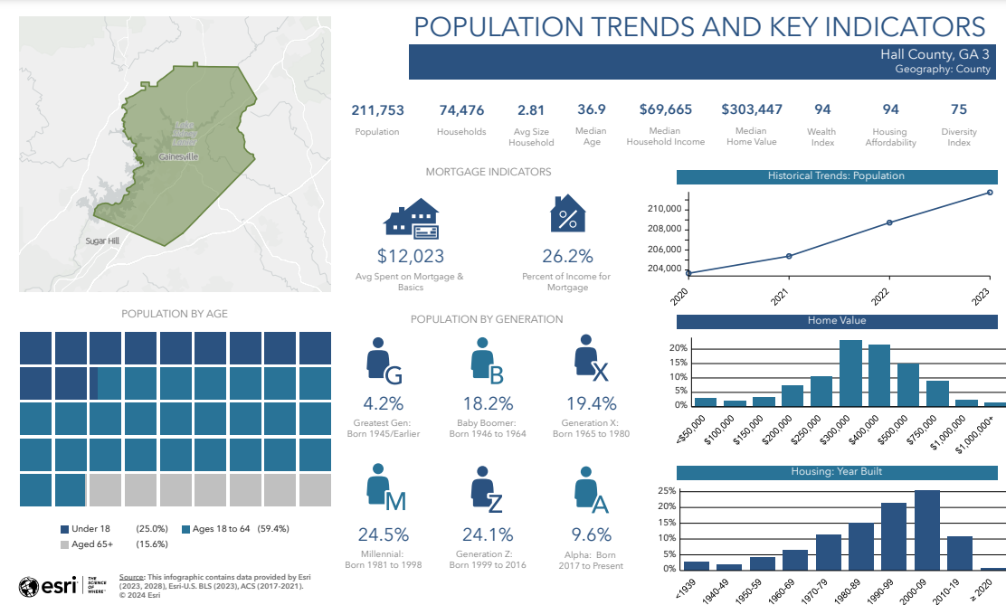Real estate market activity is cyclical and subject to the effects of both national business cycles and real estate cycles. The effects of the national business cycle are transmitted to the local economy through the linkages that tie the national economy to the basic industry and employment base of the community. The changing conditions over the successive stages of a cycle result in a shift of supply and demand within the market area.[1] Therefore, knowledge of the fundamental market forces of demand within a community is important for market analysis. These demographic and economic forces are population, employment, and income. By tracking the change in these three categories within a defined market area, the change in demand for various types of real estate can be measured. In general, a change in population is the fundamental source of demand for housing units. Similarly, office space and industrial space are linked to employment, and retail space is linked to the income earned within the market area.[2] Within this report, population and employment will be discussed on a county basis and the income on the specific competitive market area.

**Population**

Hall County is one of the most populous counties in Georgia, with its population increasing steadily over the past few decades. According to the U.S. Census, the population has grown significantly since 2010. Between April 2020 and July 2023 Hall County’s population has grown 4.24% above the State’s 3.0% growth. Hall County’s current population is approximately 211,753.

The chart above shows the population trends and key indicators for the subject market. Further, a detailed demographic analysis has been included in the addenda of this report.

Analyzing the population trend for Hall County demonstrates it is likely to continue to remain steady. With this in mind the housing sector and ancillary businesses will need to grow as well in order to keep pace. Although the demand for housing, subsidiary office, retail, and industrial space is affected by the growth in population and income earned within the community, the oversaturation in the market for these categories can decrease the demand for new supportive office, residential, retail, and industrial space until the market reaches equilibrium. Market equilibrium occurs when supply meets demand minus frictional vacancy, the space needed for easy movement within the market.

**Employment**

When analyzing the need for development in an area it is important to understand the hierarchy to the fundamental forces of demand. Typically, the engine of growth in a region is business expansion, which leads to employment growth, which leads to housing growth and finally retail growth. Hence, economic and demographic characteristics are indicators of demand, helping to establish future market trends and reflecting the economic prosperity of the region.[3]

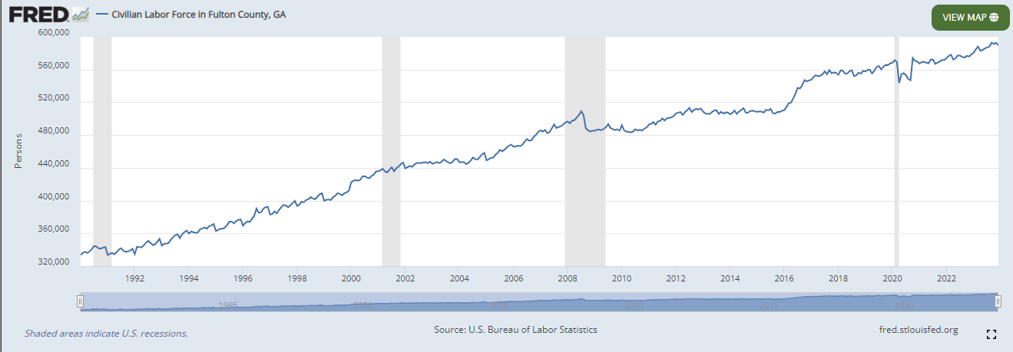

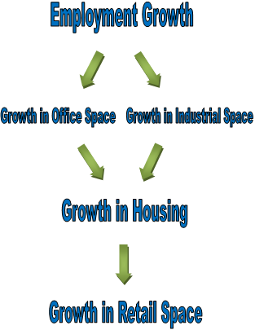

According to the Georgia Department of Labor, the 10 largest employers in Hall County are: Cottrell Inc, Fieldale Farms Corporation, Fox Racing Shox, Gold Creek Processing LLC, Kubota Manufacturing of America Corporation, Mars Chocolate North America LLC, Northeast Georgia Medical Center Inc, Northeast Georgia Physicians Group, Pilgrim’s Pride Corporation, and Walmart.

**Unemployment**

The unemployment rate is a good economic indicator; therefore, unemployment rates in an area can reflect the demand for commercial and industrial space. In general, Hall County has followed the rest of Georgia in its unemployment trend since the economic downturn, with the unemployment rate growing rapidly in 2008 and 2009, peaking at approximately 10.4% in February of 2010. However, since 2011, the unemployment rate had demonstrated a sustained overall downward trend prior to the Covid-19 pandemic. Due to the outbreak of Covid-19, unemployment rates significantly increased in the Spring of 2020, notably peaking at 10.1% in Hall County in April 2020. However, as of December 2023, Hall County’s unemployment rate has decreased to pre-pandemic levels at 2.2%, compared to the statewide rate of 3.4%.

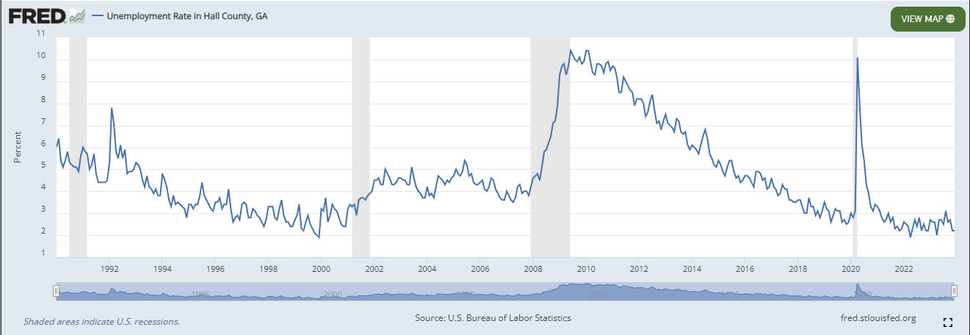

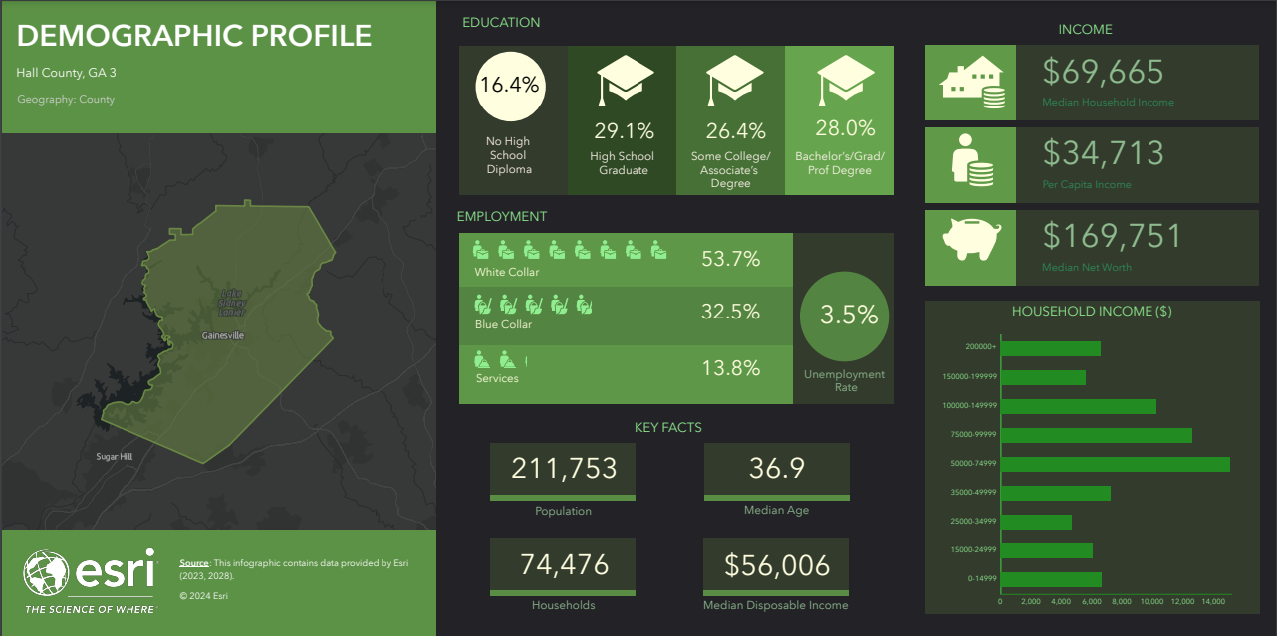

**Competitive Market Area**

The competitive market area is defined as the area where the majority of the competition occurs for the subject property. Within this section of the marketability analysis, the competitive market area of the subject will be defined as within the areas of Buford and Gainesville, in Hall County, Georgia. This was considered appropriate due to the subject’s nature as a retail building and the composition of the area.

**GAINESVILLE/HALL COUNTY RETAIL MARKET ANALYSIS**

Vacancy in the Gainesville/Hall County retail submarket is 3.8% and has increased by 0.3% over the past 12 months. During this period, there has been 30,000 SF of negative absorption, and 5,200 SF has been delivered. Within this submarket, General Retail is the largest subtype, with 6.4 million SF in this category. Rents are around $18.80/SF, which is a 4.2% increase from where they were a year ago. In the past three years, rents have increased a cumulative 15.4%. About 100,000 SF is under construction, representing a minor 0.8% expansion of inventory. In the past 12 months, 50 sales have taken place. Sales have averaged $240/SF, and the estimated value for the submarket as a whole is $200/SF. Over the past three years, there have been 223 sales, which have traded for approximately $351 million. The market cap rate for Gainesville, Hall County is 6.7%, slightly below its trailing three-year average of 6.9%.

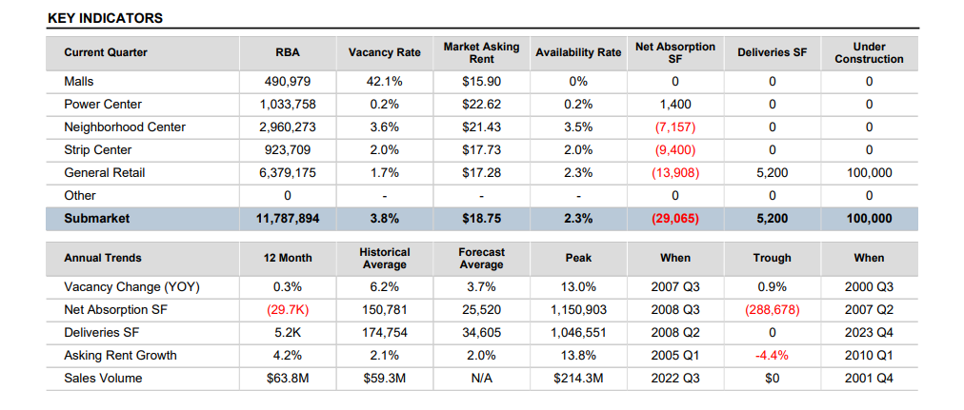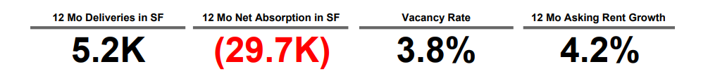

**Leasing**

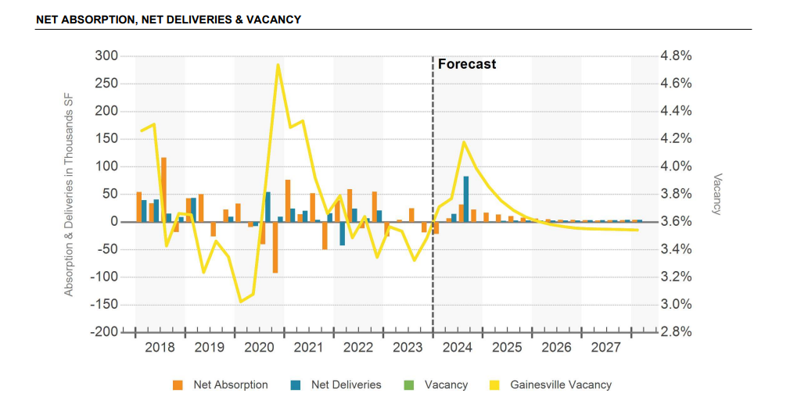

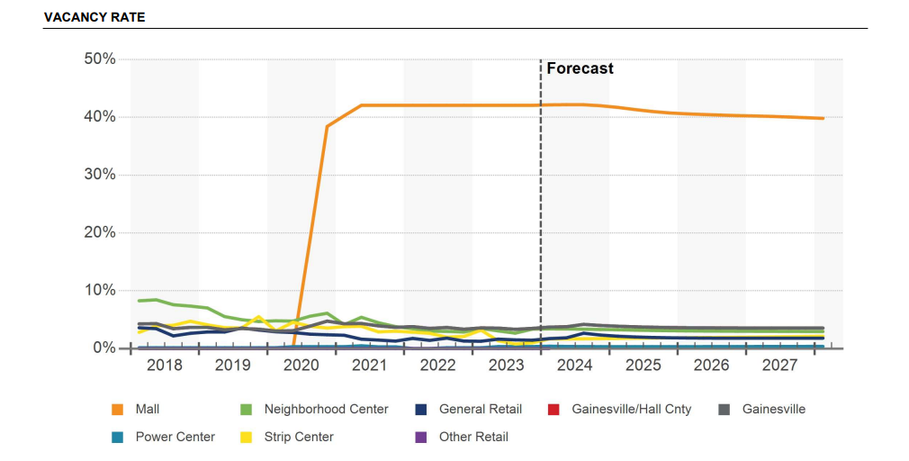

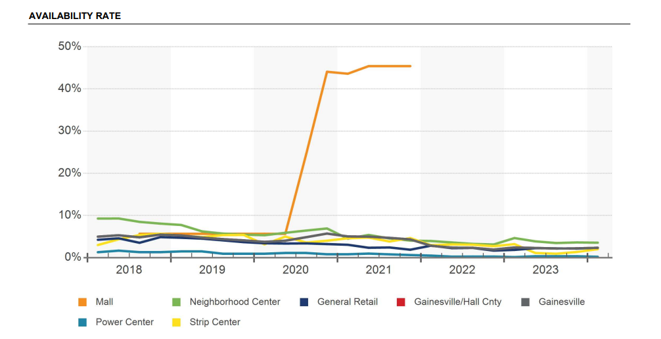

**Rent**

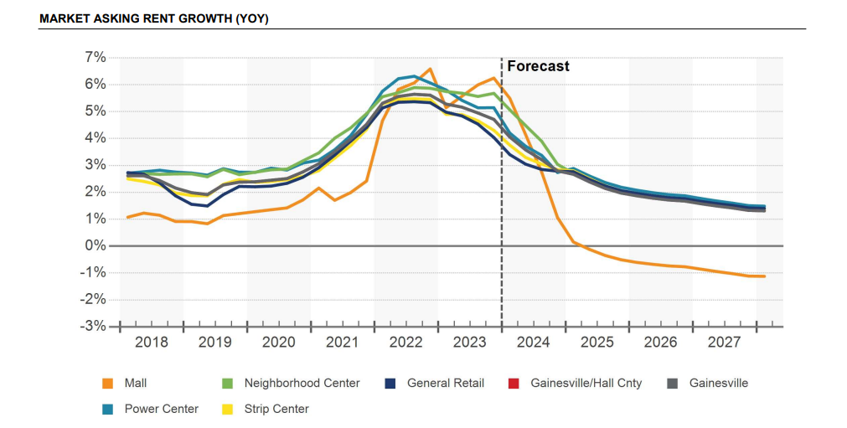

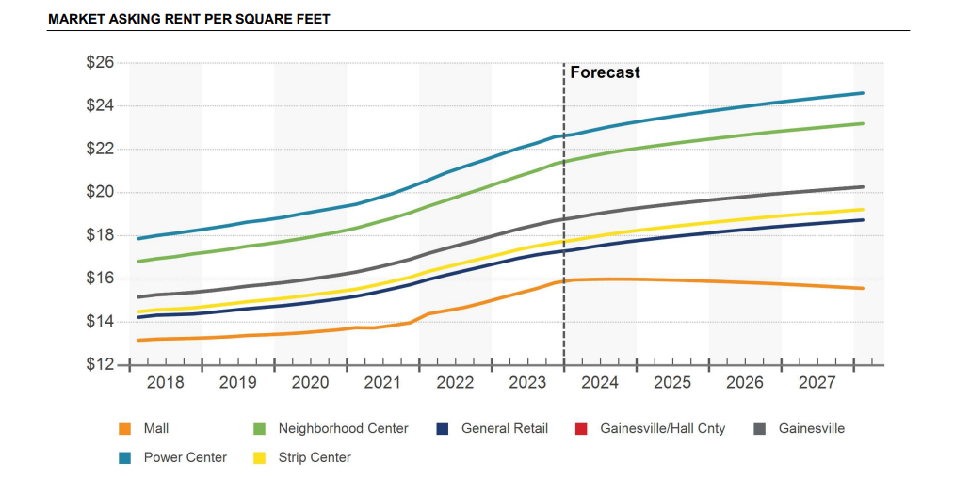

**Construction**

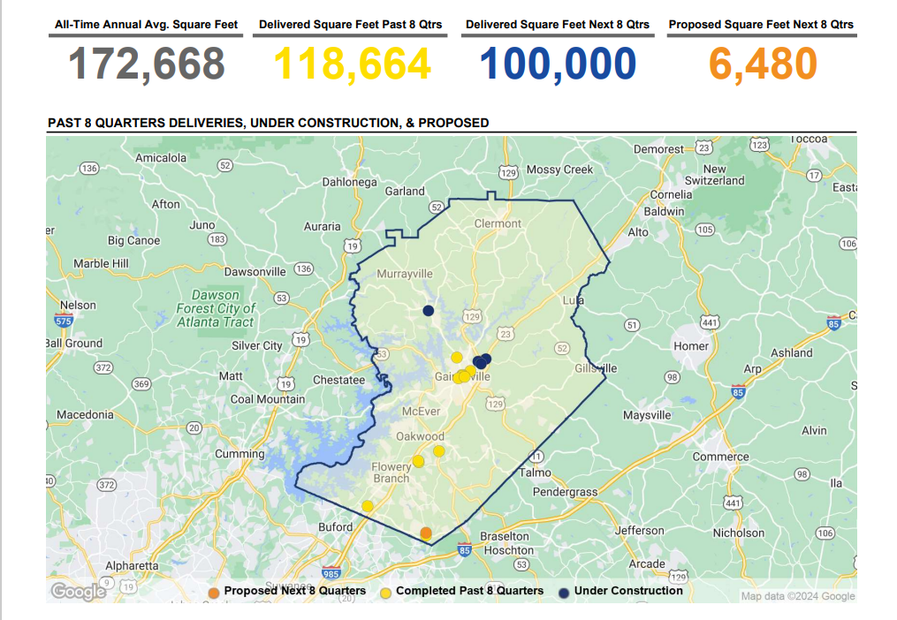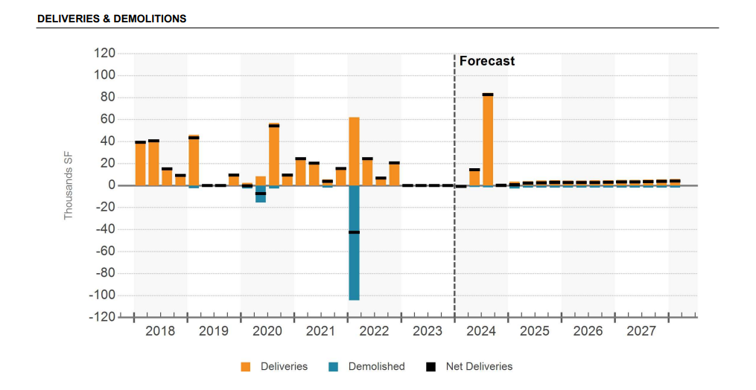

**Sales**

Investors have been especially active in the capital markets in Gainesville, Hall County, making it one of the most heavily traded submarkets in the region over the past several years. Annual sales volume has averaged $98.3 million over the past five years, including a 12-month high of $214 million over that stretch. The recorded transaction volume here reached $63.6 million in the past year. The general retail sector drove that volume. Market pricing, based on the estimated price movement of all properties in the submarket, sat at $200/SF during the first quarter of 2024. Pricing is down a pinch since the first quarter last year. The market cap rate has shrunk since last year to 6.7%. That is the lowest cap rate in the past five years, which is the same as the metro's average.

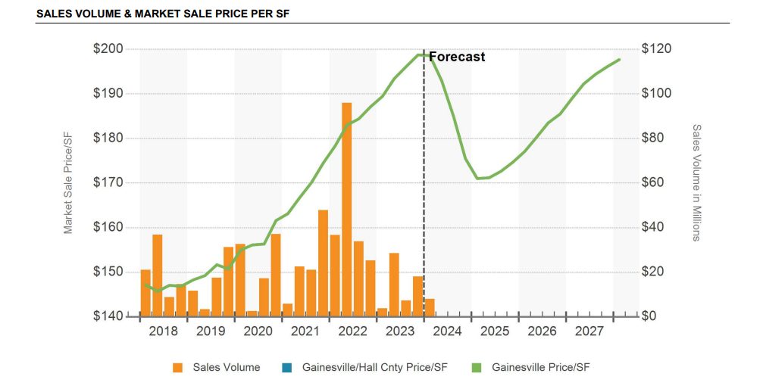

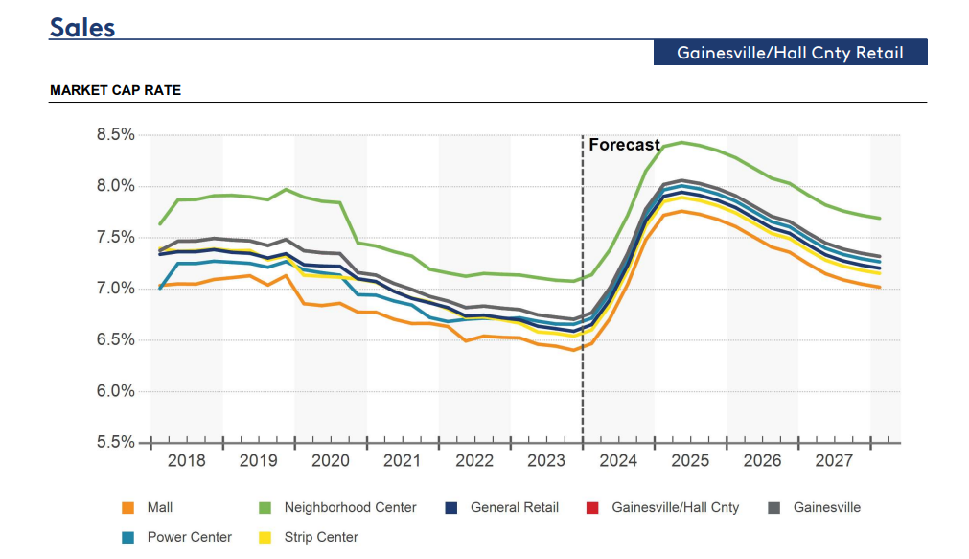

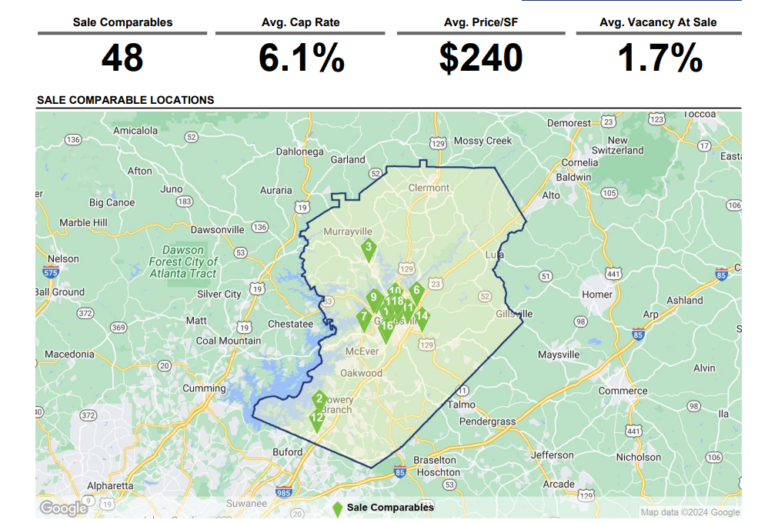

**GAINESVILLE/HALL COUNTY OFFICE MARKET ANALYSIS**

The Gainesville/Hall County office submarket has a vacancy rate of 4.3%. This vacancy rate is 0.4% lower than it was this time last year. There was 65,000 SF of positive absorption and 43,000 SF of net deliveries. Rents have increased by 2.0% in the past 12 months and are currently around $20.00/SF. Roughly 44,000 SF is under construction in the Gainesville/Hall County office submarket. In the past year, there have been 21 sales, which have traded for approximately $21.7 million in volume and 150,000 SF in stock. Vacancy is 11.5% in 4- & 5-Star buildings, and 6,800 SF has been absorbed in this asset class over the past year. In 3 Star buildings, 4.5% of space is vacant, and 51,000 SF has been absorbed over the past year. Currently, 3.3% of 1- & 2-Star space is vacant, and 7,100 SF has been absorbed in this space type over the past 12 months. Of the 21 sales in the past year, none were of 4-& 5-Star buildings, 6 were of 3-Star buildings, and 15 were of 1-& 2-Star buildings. Current vacancy lower than its trailing three-year average of 4.6%, however; current vacancy matches the 4.6% trailing three-year average of the Gainesville market. The submarket is approximately 76,000 SF larger than it was three years ago and is the result of roughly 120,000 SF of construction and roughly 45,000 SF of demolition. Rents have increased by 14.6% over the past three years, which matches the Gainesville market average for the same period. There have been 102 sales over the past three years, amounting to $128 million in volume and 840,000 SF of inventory.

CoStar's estimated cap rate for Gainesville/Hall County has averaged 9.6% over the past three years, which is lower than the current estimated cap rate of 10.2%. The total Gainesville /Hall County office submarket comprises 5.3 million SF of inventory.

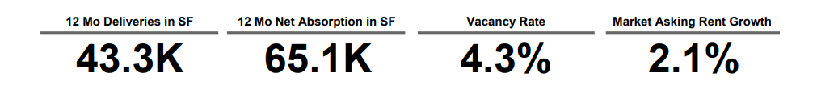

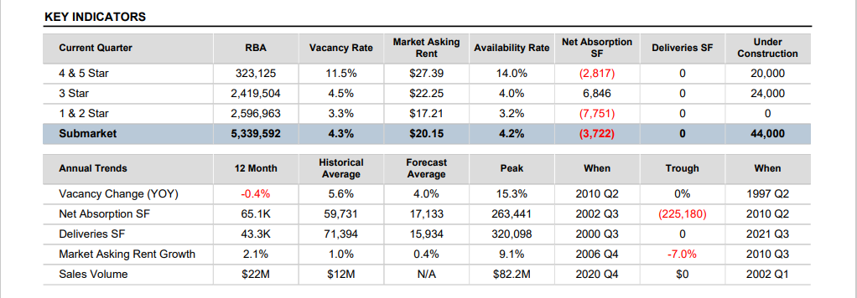

**Leasing**

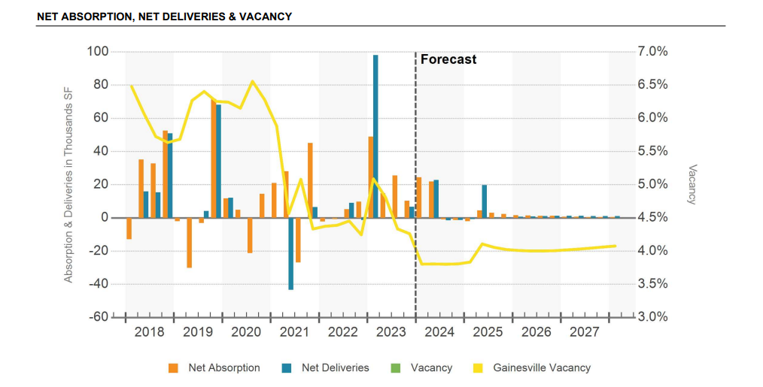

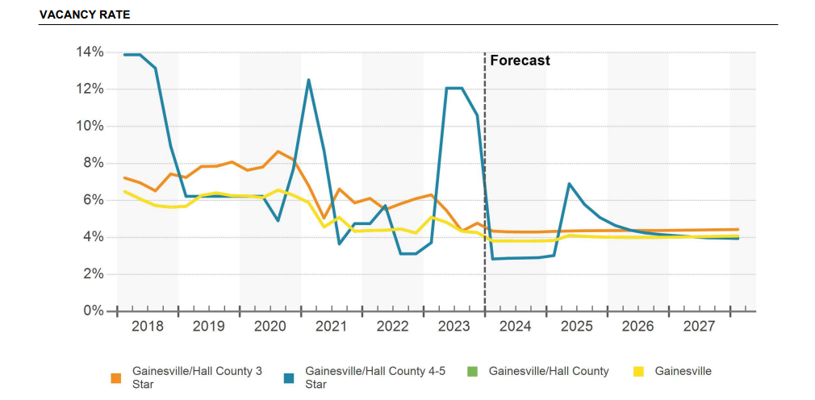

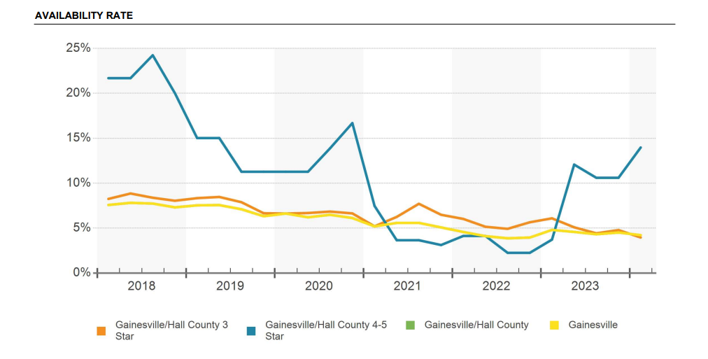

**Rent**

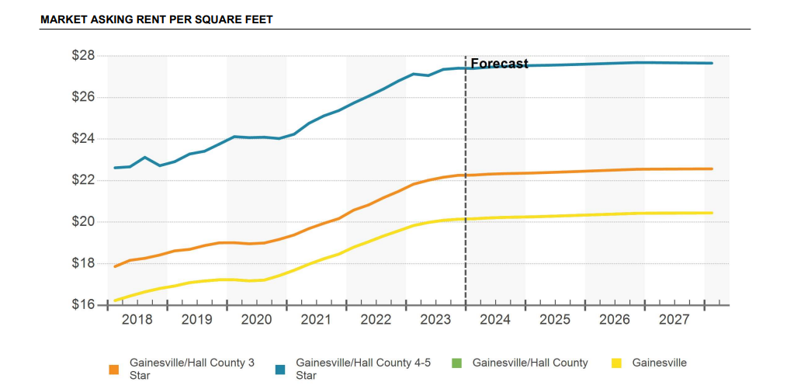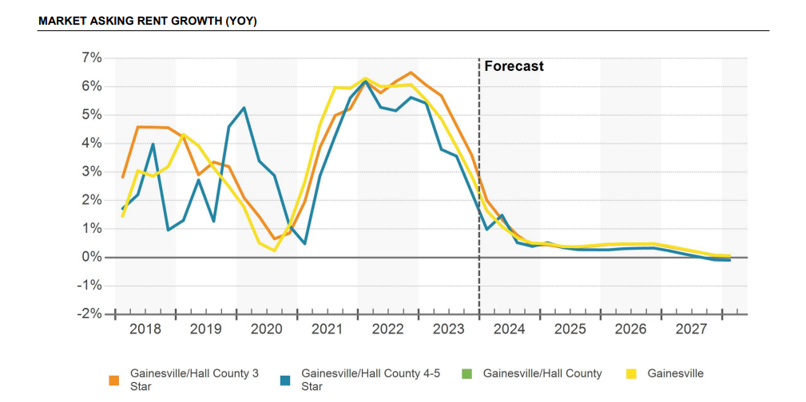

**Construction**

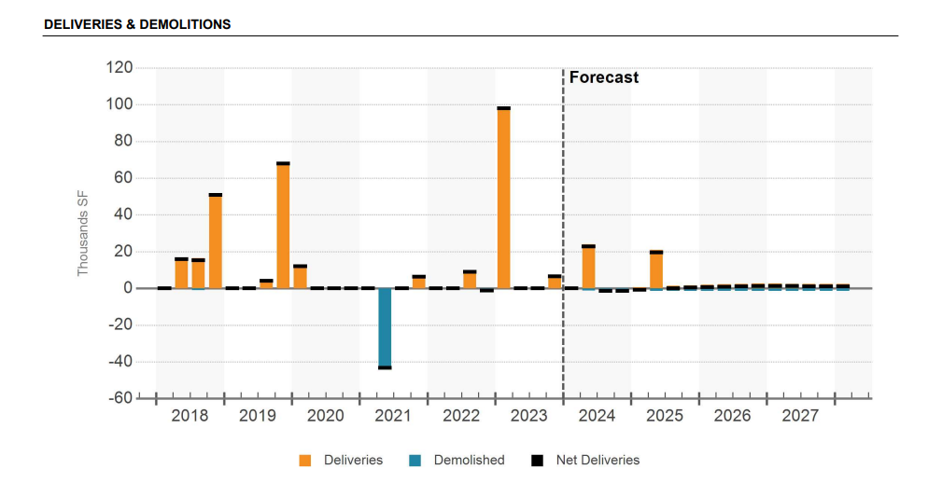

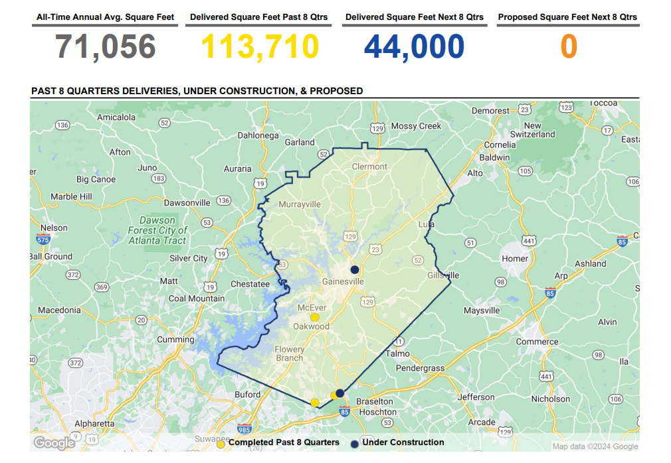

**Sales**

There have been 21 sales in the Gainesville/Hall County office submarket over the past year, amounting to $21.7 million of volume and 100,000 SF of stock. These sales have averaged $202/SF, which is greater than the estimated submarket price of $144/SF. During this time, trailing one-year price per SF averages were as high as $282/SF and as low as $186/SF. Over the past three years, Gainesville/Hall County has averaged 36 sales per year, $54.0 million of volume per year, and 350,000 SF of stock per year. The 21 sales in the past 12 months include 6 buildings rated 3 Star, and 15 buildings rated 1 & 2 Star. The 3 Star buildings traded for $12.3 million, or $198/SF on average. The 1-& 2-Star buildings traded for $9.4 million, or $210/SF on average. Over the past three years, transaction cap rates have averaged 6.9%. The market cap rate, or the estimated cap rate for all buildings in the submarket, is 10.2%, equaling the Gainesville market average. Within Gainesville/Hall County, 4-& 5-Star buildings have a market cap rate of 10.1%, 3 Star buildings have a market cap rate of 9.8%, and 1-& 2-Star buildings have a market cap rate of 10.5%.

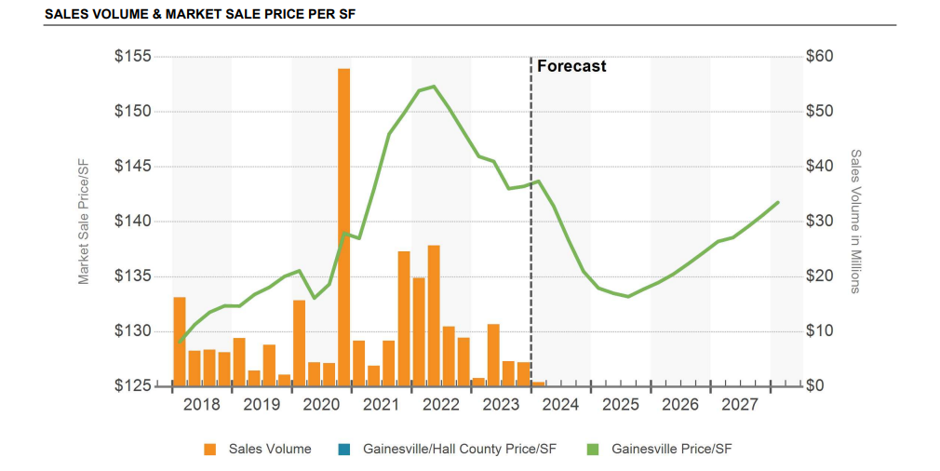

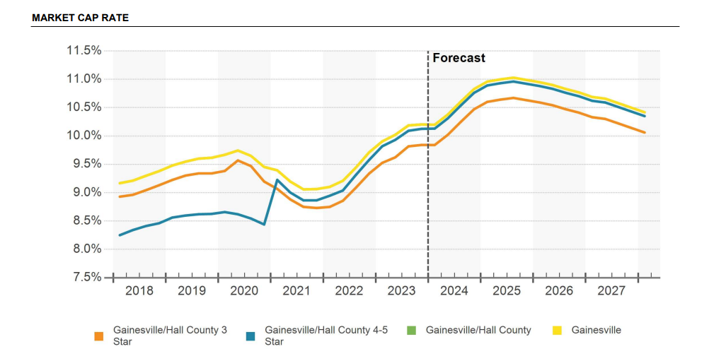

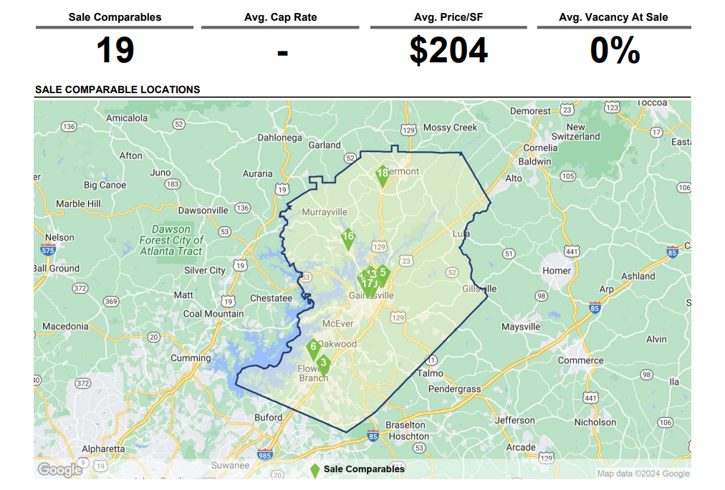

**Conclusion**

Hall County is a desirable area as evidenced by its rate of growth over the last few decades. Additionally, Hall County’s projected population growth rate from 2023 to 2028 is 2.62%, which is slightly above Georgia’s projected population growth rate from 2023 to 2028 of 2.58%. The Hall County unemployment rate has been consistently declining since 2010, not considering the spring and summer 2020 unemployment figures caused by the Covid-19 pandemic, currently Hall County’s unemployment rate is 2.2%. As demonstrated by the demographic profile, the population and number of households within a one, three, and five-mile radius of the subject have increased significantly since 2010, with considerable growth projected through 2028 in the subject’s competitive market area.

In the subject’s competitive market area, vacancy rates are currently around 14% vacancy, the rental rates have gradually increased, and the unemployment rate is on an overall downward trend. Therefore, based on the above analysis, the office development in the Gainesville, Hall County submarket is considered to be in average demand, with the potential for greater demand as the economy continues to expand. Considering the subject’s location, the composition of the competitive market area, and the subject’s compatibility with nearby developments, the subject is considered to be in average demand within this submarket.

**SUBJECT’S LOCATION**

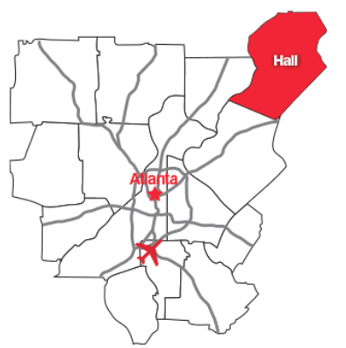

The subject is located on the north side of Lanier Island Pkwy/GA Hwy 347, southeast of GA Hwy 13, northwest of Interstate 985 and south of Wade Orr Rd in the City of Buford, Hall County, Georgia. The subject’s neighborhood is bordered by the following arterial routes: Lanier Island Pkwy/GA Hwy 347 to the south, GA Hwy 13 to the west, and Interstate 985 to the east.

Lanier Island Pkwy/GA Hwy 347 is a minor arterial route with approximately 26,579 vehicles per day on average and provides access to GA Hwy 13 (with 11,600 vehicles per day) and Interstate 985 (that has 55,305 vehicles per day). GA Hwy 13 is approximately 1 mile west of the subject and is an arterial route that travels parallel to Interstate 985. Wade Orr Rd is an east-west collector road between Interstate 985 and McEver Rd, approximately 3 miles north of the subject. Finally Interstate 985 is a major arterial route originating in northeast Gainesville, traveling south through Hall County, along the east side of Buford, and in Gwinnett County connecting with Interstate 85 near the City of Suwanee.

The subject is located within the city limits of Buford amidst an area characterized by retail and office developments. West of the subject is predominately multi-family, single-family residents, and vacation cottages near Lake Lanier. South and east of the subject are residential properties and commercial properties. With the commercial properties near the intersection of GA Hwy 347 and Interstate 985 into the downtown area of Buford. Lastly, North of the subject is Lake Lanier, recreational properties, undeveloped land and agricultural developments. Additional development in the area includes Lake Lanier, Cherokee Bluffs, Shoal Creek Campground, Margaritaville at Lanier Islands, Buford Dam Park, Friendship Elementary School, Buford Elementary, Middle and High School, Neighborhood healthcare Center, Emory Hospital at Buford, and Northeast Georgia Medical Center.

Directly across from the subject is the newly constructed Lanier Logistics Center, a 112-acre master-planned park with two buildings totaling 1M+ square feet. The current tenant for both buildings is Amazon.

**Conclusion**

Hall County has experienced steady growth over the last few decades with population growth at a rate higher than the statewide rate since 2010. The area has multiple recreational venues and has become a popular retirement and second homeowner’s location, which contributes to the county’s economic base. In addition, the area is influenced by the presence of Brenau University, the University of North Georgia, and Lanier Technical College. Overall, the City of Buford’s population growth rate and median home value are well above the statewide medians. Therefore, it is the appraiser’s opinion that prospects for long-term economic growth in the subject area are considered average as more employment centers are developed in Hall County. **AREA MAP**

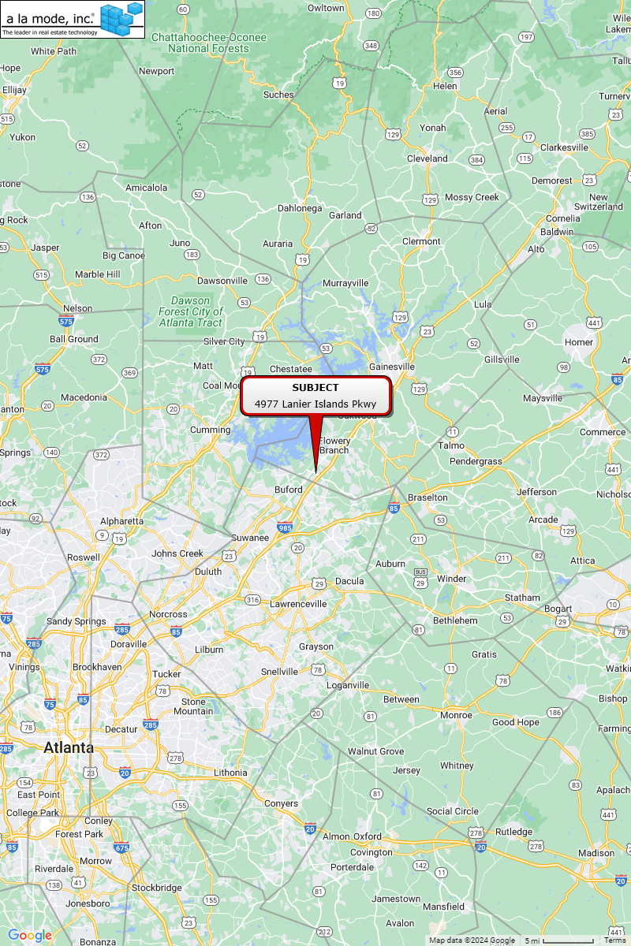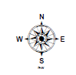**IMMEDIATE AREA MAP**

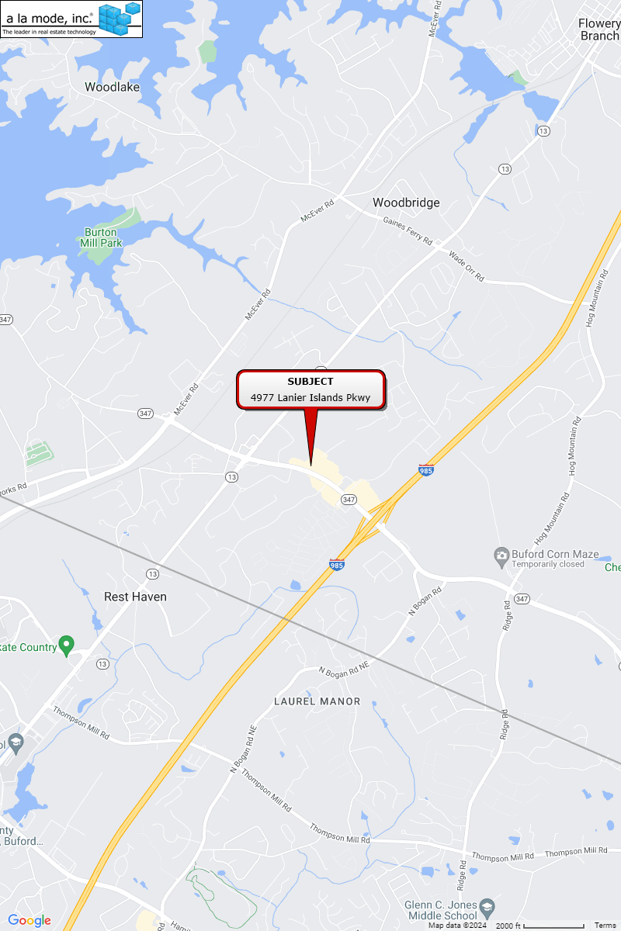**PROPERTY HISTORY**

Based on the available records the last transaction to occur on the subject property was a Limited Warranty Deed on October 23, 2015, for $3,000,000 with the grantor being BRC Friendship LLC, and the grantee being Wagner Friendship Shoppes LLC according to Hall County Book/Page (7606/280).

To the best of the appraiser’s knowledge, the subject property has not been listed or sold within the previous three years prior to the appraisal date, except for what is noted above. Additionally, to the best of our knowledge, the subject is not currently listed or pending sale.

The property history has been provided by conversations with various individuals involved with the chain of titles, public records, and CoStar. The appraisers have not performed a title search, nor do the appraisers warrant that the history, as presented herein, is completely accurate since the appraisers have relied upon the information of others. Any person or entity contemplating an interest in the subject property should rely solely upon a title search and opinion prepared by a qualified attorney-at-law.

**REAL ESTATE TAXES**

Real estate tax assessments are administered by the subject’s municipality in which the subject is located and are estimated by jurisdiction on a county basis. Real estate taxes in this state and this jurisdiction represent ad valorem taxes, meaning a tax applied in proportion to value.

The subject property is taxed by Hall County based on an assessment made by the tax assessor. In this case, the statutory assessment rate is 40% of "fair market value”. Real estate taxes and assessments for the current tax year are shown in the following table.



The subject property real estate taxes are current and have been paid.

**SITE DESCRIPTION**

**Location**

The subject is located on the north side of Lanier Island Pkwy/GA Hwy 347, southeast of GA Hwy 13, northwest of Interstate 985, and south of Wade Orr Rd in the City of Buford, Hall County, Georgia.

**Site Size**



**Tax Map**

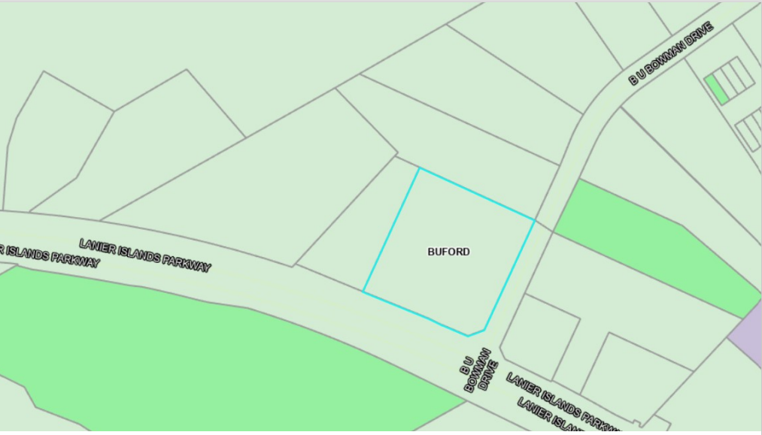

**Frontage, Access, and Topography**

The subject property contains 2.44 acres, and it fronts approximately 300 feet along Lanier Island Pkwy/GA Hwy 347 and 325 feet along B U Bowman Dr. The site has a level topography. Access is provided via three curb cuts (one along Lanier Island Pkwy/GA Hwy 347 and two along B U Bowman Dr). Access onto the property is considered average for the area.

**Utilities and Services**

Utilities and services include police/fire protection, water/sewer, electricity, natural gas by a provider of choice, and telephone service.

**Drainage and Soil Conditions**

The building site appears to have adequate drainage with positive flow to the southwest.

The physical inspection of the property did not reveal any apparent evidence of adverse soil or subsoil conditions. A formal study was not undertaken, and we are not qualified to detect such soil conditions. Therefore, we recommend that the client retain an expert in this field of study, if desired.

**Easements, Encroachments and Restrictions**

The appraiser was not provided with a current title report to review. Our valuation assumes no adverse impacts from easements, encroachments, or restrictions, and further assumes that the subject has clear and marketable title.

**Environmental Hazards**

The physical exterior and interior inspection of the property did not reveal any apparent evidence of hazardous waste materials. A formal study was not undertaken as the appraisers are not qualified to detect such substances and, if desired, recommend that the client retain an expert in the field.

**Conclusion**

In conclusion, the site is considered to have average physical utility for the development of a retail building. This opinion is based on the site's physical configuration, usable topography, average accessibility, average visibility, and the availability of utilities.

**FLOOD MAP**

According to Flood Insurance Maps (FIRM) 13139C0289G dated April 4, 2018, the subject is located within Zone X, an area not prone to flooding. The associated flood plain map is shown below.

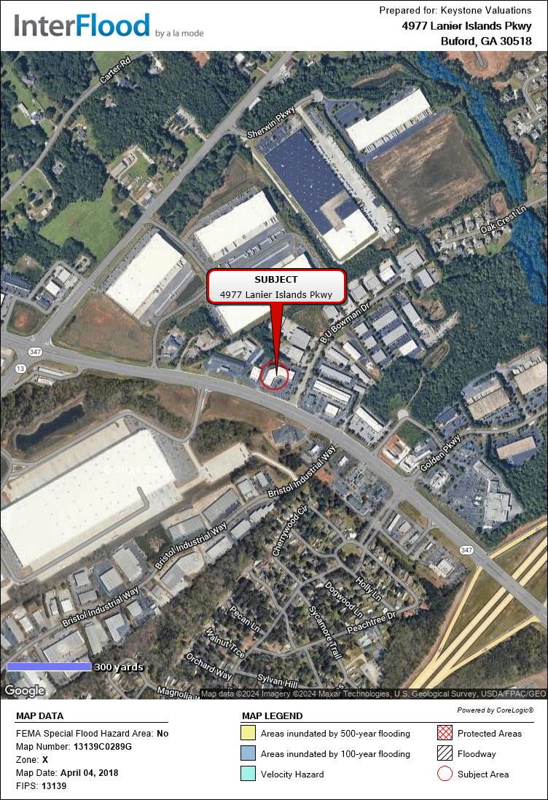

**IMPROVEMENTS DESCRIPTION**

The subject property is located on the northwest corner of Lanier Islands Parkway and B U Bowman Drive within the City of Buford, in Hall County, GA. The subject property is improved with a one-story retail building which contains 23,450 rentable square feet and was built in 2001. As of the effective date, the property is estimated to be 88% leased to multiple tenants. The property is situated on one tax parcel which contains 2.44 acres. The subject is zoned C-2, General Business District within the City of Buford.

**Overall Improvement Discussion**

The rentable area of a floor is normally computed by measuring to the inside finished surface of the dominant portion of the permanent outer building walls, excluding any major vertical penetrations of the floor. No deductions are made for columns and projections necessary to the building.

Theoverall building and site improvements are in average condition as of the date of the appraisal. Thus, the property has average overall market appeal. The property is assumed to have average tenant improvements, typical for this type of property. Further, the descriptions below are based on a combination of a Keystone inspection, public records and/or broker provided information.

**Effective Age and Economic Life**



**General Construction Details**

**Footing & Foundations** : Concrete over 4" gravel base with reinforced concrete footings. Assumed.

**Roof** : Flat, material unviewable, assumed.

**Exterior Walls** : Brick/Masonry

**Interior Walls** : 1/2” Painted Sheetrock

**Floors** : Carpet/Vinyl/Tile/Concrete

**Ceilings** : 2x2 acoustical tile

**Electrical** : Assumed Adequate

**Lighting** : Florescent lighting and can lighting throughout

**Plumbing** : Assumed Adequate

**HVAC** : Central HVAC

**Windows and Doors** : Double Pane Windows in Wood Casing Throughout, Assumed. Aluminum frame and glass with solid interior wood doors, Assumed.

**Fire Security**  : Hand-held fire extinguishers are strategically placed throughout, Assumed.

**Sprinkler** : Yes

**Parking** : 116+/- Total Parking Spaces. The condition of the parking area is average. The parking area is asphalt lined with surface spaces.

**Recent Renovations**

The subject property does not have any noted renovations, upgrades, or repairs. The subject has been well-maintained.

**Deferred Maintenance (or Capital Expenditures)**

The subject does not have any applicable deferred maintenance.

**Furniture, Fixtures & Equipment (FF&E)**

There is no noted personal property or FF&E which provides contributory value to the

subject property.

**Americans with Disabilities Act**

Based on the inspection and information provided, I am not aware of any ADA issues. However, I am not an expert in ADA matters and further study by an appropriately qualified professional is recommended to assess ADA compliance.

**ZONING**

According to the City of Buford, the subject property is zoned C-2 General Business District. The C-2 General Business District is intended to provide adequate space in appropriate locations along major streets, thoroughfares and at intersections for various types of business use. These uses will include the retailing of major goods and services, general office facilities and public functions that would serve a community area of several neighborhoods. Development of uses in the district characteristically occupies a large area because it is intended to serve a greater population and to offer a wider range of services.

Permitted uses include business offices, retail facilities, art galleries, bakeries, banks or financial institutions, clothing sales or rental stores, department stores, drug stores, hotels, recreation facilities, sporting goods stores, offices, medical offices, and a wide variety of other commercial uses.

Limitations include a maximum height of 10 stories, minimum front setback of 50 feet, minimum side setback of 10 feet, and minimum rear setback of 15 feet.

While this is not intended to represent a legal opinion, the subject improvements are considered to be in conformity with the zoning ordinance.

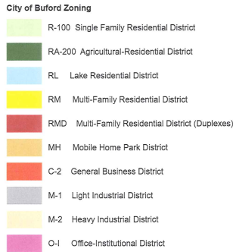

**Subject**

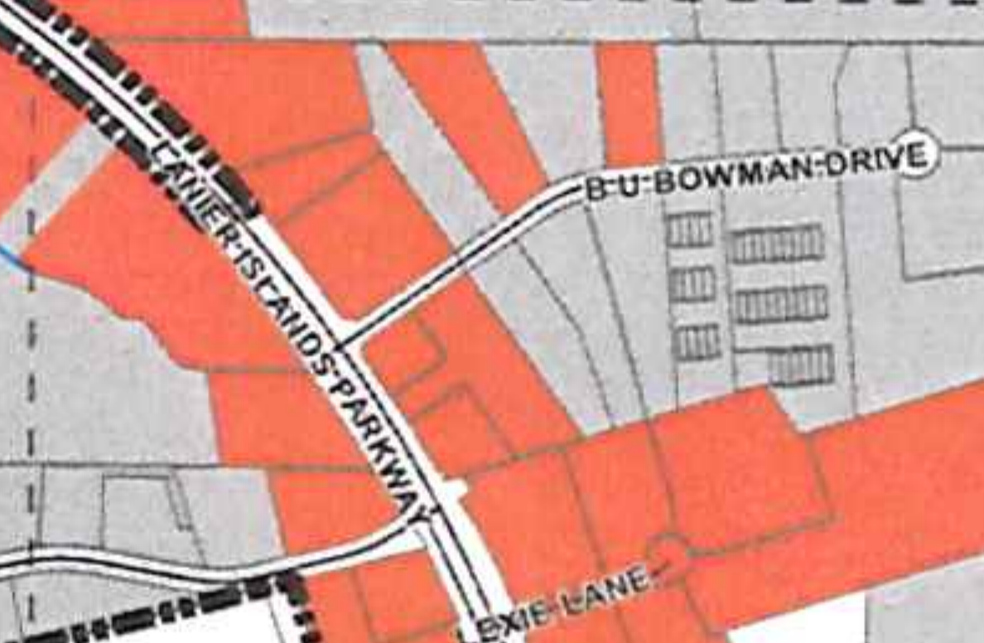*City of Buford Zoning Map*

**HIGHEST AND BEST USE**

Highest and Best Use is defined in Chapter 17 Page No. 306, in the 15th edition of "The Appraisal of Real Estate", published by the Appraisal Institute, and adopted by FDIC as the reasonable and probable use that supports the highest present value of vacant land or improved property, as defined, as of the date of the appraisal. Also implied within these definitions is that the determination of highest and best use results from the appraiser's judgment and analytical skill, i.e. that the highest and best use determined from analysis represents an opinion, not a fact to be found. The use of property must be physically possible, legally permissible, financially feasible, and maximally productive to represent the highest and best use.

In cases where a site has existing improvements, the highest and best use may very well be different from the existing use. However, the existing use will continue unless and until the land value, in its highest and best use, represents the premise upon which value is based.

***Highest and Best Use As Improved***

**Legally Permissible**

As detailed in the zoning section of this report the subject is currently zoned C-2, General Business District. The site and improvements appear to meet the legal requirements of the current zoning ordinance. Therefore, the subject property conforms to the area’s zoning restrictions and its land use is considered consistent with the subject property’s location and nature of the market area. In general, the subject property’s location is suited for commercial building development due to its commercialized location along Lanier Islands Parkway within the City of Buford, in Hall County, GA.

The possibility of rezoning the site for other uses other than a commercial (neighborhood) district was also considered. However, any zoning other than commercial use, (i.e. agricultural or residential) would not be considered a logical alternative, since it would be inconsistent with the subject’s position along Lanier Islands Parkway, near other commercial properties in the Buford area.

**Physically Possible**

The physical characteristics of a site that affect its possible use(s) include, but are not limited to, location, street frontage, size, street access, availability of utilities, easements, soil and subsoil, and topography.

The site is square shaped and large enough, with a suitable configuration for commercial development. No adverse easements were observed, and there is currently ingress/egress from Lanier Islands Parkway and B U Bowman Drive. All utilities are available on the site. No soil or subsoil is known to have an adverse effect upon the development potential of the site.

The subject site is developed with a one-story retail building containing a combined 23,450 square feet that is leased to multiple tenants. Given the improvements are already constructed and are in use without any physical barriers restricting its occupancy, it is my opinion that as improved, a continuation of the current use is physically possible.

**Financially Feasible**

The subject site is located in a commercial area. Commercial developments in this area have been successful in the past, due to the location, accessibility, proximity to primary transportation routes and the overall desirability of the area as well as its proximity to other employment centers and arterial routes.

The rate of population in Buford and Hall County has decreased over the last few years while the employment growth in the same area has gradually increased, thereby creating a demand for commercial and residential development. Additionally, the subject’s market area has the necessary characteristics and infrastructures to sustain further growth and development in the future as the economy expands, reinforcing market demand for the subject site.

The subject site is large enough to permit the development of a commercial building. The property’s expected current and future capacity for generating a net income more than expenses suggests that the current retail building would be financially feasible at this time.

**Maximally Productive**

In order to determine the type of development that would result in maximum productivity from the subject property, an analysis was performed. There are no other legally permissible or physically possible uses that could produce a greater positive cash flow other than the current retail building, as it is the appraisers’ opinion use of the subject property for agricultural or residential uses is not considered reasonably probable given the subject property location, topography, zoning, access, physical characteristics, and its location near existing commercial buildings.

Based on the definition of maximally productive, the selected land use must yield the highest value of the possible uses.[4] As provided above, there are no other possible uses that are legally permissible, physically possible, and potentially financially feasible, other than as a retail building, and it is the appraisers’ opinion that the use that yields the highest value of as a retail building. As presented in the analysis found later in this report, a retail building is capable of producing a positive net income. Furthermore, due to the projected demand found in the subject property area and the positive net income indicated by the Income Approach, it is the appraisers’ opinion that there is not any other physically possible, legally permissible, or financially feasible use that would be more productive than commercial use, specifically as a retail building. Therefore, a retail building is considered to be the maximally productive use of the subject property.

**Highest and Best Use - As Improved Conclusion**

The subject property is zoned C-2, General Business District; the site has no inherent physical characteristics which might limit its use as a commercial development. The site and improvements appear to meet the legal requirements of the current zoning ordinance. Based on analyses found in this appraisal, the current retail building would meet the test of feasibility by producing a positive net income. Other uses may meet the test of economic feasibility; however, continued use as a retail building is considered maximally productive. Therefore, the Highest and Best Use, as improved, is in its current use as a retail building.

**Highest and Best Use - As If Vacant Conclusion**

Given the site’s functional physical characteristics, size and C-2 General Business District zoning, commercial development seems probable. Commercial development would be physically possible and legally permissible and would also be compatible with the surrounding improvements. Based on current cost figures found in the appraiser’s files including land, the financial feasibility for a new commercial development under current regional market conditions reveals that development of such a project on the subject’s site would produce a positive cash flow and/or an adequate return to the cost of the improvements. Therefore, based on these considerations, developing as a commercial development is considered the highest and best use, as if vacant.

**APPRAISAL METHODOLGY**

Three basic approaches may be applicable and utilized, then reconciled to arrive at an estimate of market value. An approach to value is included or eliminated based on its applicability to the property type being valued and the information available. The reliability of each approach depends on the availability and comparability of market data as well as the motivation and thinking of purchasers. Applicable approaches and whether they were utilized are summarized below:

**Cost Approach**

The Cost Approach is based on the proposition that an informed purchaser would pay no more for the subject than the cost to produce a substitute property with equivalent utility. In the Cost Approach, the appraiser forms an opinion of the cost of all improvements, depreciation from physical, functional, and external causes. The land value, entrepreneurial profit and depreciated improvement costs are then added, resulting in indication of value.

**Sales Comparison Approach**

The Sales Comparison Approach compares sales of similar properties with the subject property. Each comparable sale is adjusted for its inferior or superior characteristics. The values derived from the adjusted comparable sales form a range of value for the subject. A gross income multiplier and / or effective gross income multiplier may also be analyzed. By process of correlation and analysis, a final indicated value is derived.

**Income Approach**

In the Income Capitalization Approach the income-producing capacity of a property is estimated by using contract rents on existing leases and by estimating market rent from rental activity at competing properties for the vacant space. Deductions are then made for vacancy and collection loss and operating expenses. The resulting net operating income is divided by an overall capitalization rate to derive an opinion of value for the subject property. The capitalization rate represents the relationship between net operating income and value. This method is referred to as Direct Capitalization.

Related to the Direct Capitalization Method is the Yield Capitalization Method. In this method periodic cash flows (which consist of net operating income less capital costs) and a reversionary value are developed and discounted to a present value using a discount rate or an internal rate of return. The Income Approach converts the anticipated flow of future benefits (income) to a present value estimate through a capitalization and or a discounting process.

**Final Reconciliation**

The appraisal process concludes with the Final Reconciliation of the values derived from the approaches applied for a single estimate of market value. Different properties require different means of analysis and lend themselves to one approach over the others.

**Analyses Applied**

Applicability and utilization of the approaches in this assignment is described as follows.

|  |  |  |  |
| --- | --- | --- | --- |
| **Approach** | **Description** | **Applicability** | **Utilization** |
| Cost | A cost approach is most applicable in valuing new or proposed construction when the improvements represent the highest and best use of the land and the land value, cost new and depreciation are well supported. | Not Applicable | Not Utilized |
| Sales Comparison | A sales approach is most applicable when sufficient data on recent market transactions is available and there is an active market for the property type. | Applicable | Utilized |
| Income | An income approach is most applicable when the subject is an income producing property or has the ability to generate income in the future as an investment. | Applicable | Utilized |

**LAND TO BUILDING RATIO’S**



To determine if the subject’s land-to-building ratio indicates surplus or excess land or if the subject’s land-to-building ratio falls below the indicated comparable range, an analysis was performed on the comparables found within the Sales Comparison Approach. The comparable sales indicate a land-to-building ratio between 4.18/1 to 11.88/1. Based on the above analysis, the subject property falls within the land-to-building ratios range found in the comparable sales. Therefore, it is our opinion that due to the configuration of the site, the zoning frontage requirements, and the positioning of the subject, the subject property has ample land to support the subject’s building size and does not have excess or surplus land.

**SALES COMPARISON APPROACH**

The Sales Comparison Approach is based on the principle of substitution, considering that a prudent investor would pay no more for a property than the cost to acquire another property of equal desirability or utility. When enough data is available the Sales Comparison Approach provides a reliable indication of value and provides insight into the actions of buyers and sellers. Valuation of the subject property by the Sales Comparison Approach utilizes the sales price per square foot of building including land.

Sales were researched for this analysis, which are documented on the following pages, followed by a location map, adjustment summary and an analysis grid. All sales have been researched through numerous sources and, when possible, verified by a party to the transaction. The comparable sale data sheets are included in the Addendum of this report.



 **SALES COMPARABLE MAP**

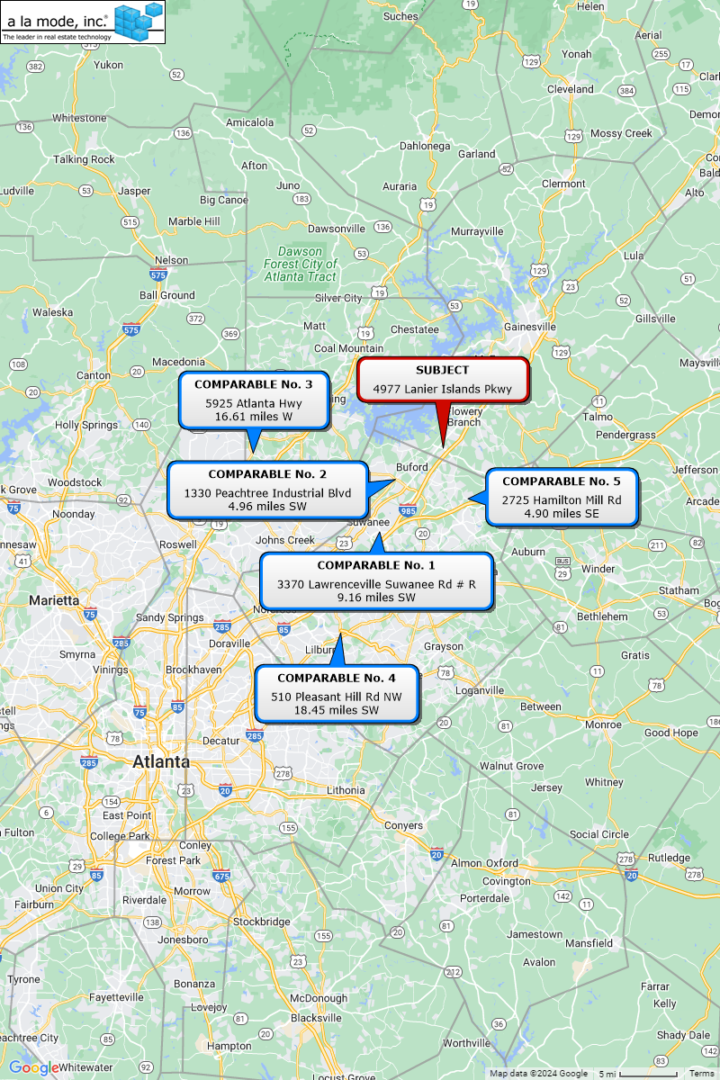

**Analysis and Discussion of Improved Sales**

The comparable sales have been analyzed and compared with the subject property. Adjustments are discussed in the summary below and shown in the sale adjustment grid that follows.





**Sales Comparison Approach Conclusion**

After adjustments, the sales ranged from $164.60/SF to $251.69/SF, with an average of $217.34/SF. Due to the heavy number of adjustments, all the value indications have been considered for this analysis.

After considering the comparable building sales with respect to time, location, condition, size, building type and market demand, a sale price per square foot of $218.00 is considered reasonable and supported.

23,450 square feet x $218.00 = $5,112,100

**As Stabilized Market Value (RD) $5,110,000**

Less: Lease Up Costs -$50,000*

**As Is Market Value $5,060,000**

**SALES COMPARISON APPROACH:**

**MARKET VALUE AS IS (rounded) = $5,060,000**

*\*Lease-up costs are calculated in the Income Approach that follows.*

**INCOME APPROACH - OVERALL CAPITALIZATION**

The Income Approach is based on the principle of anticipation, considering that the value of a property may be measured by the present worth of anticipated future benefits accruing to the ownership and use of the property. The Income Approach also reflects the attitudes of investors in income properties and their requirements for returns on investments. All capitalization or discount methods are based upon the concept of time preference, which holds that future income or benefits are worth less than the same income or benefits received now, and they decrease systematically as the time for receipt is deferred into the future.

A value estimate by the Income Approach has been made which reflects current income and expense data on comparable buildings in the subject area and other areas influenced by similar economic factors.

**Occupancy and Rent Roll Discussion**

The subject property is 23,450 sq. ft. retail property that is approximately 88% leased to nine tenants with two units vacant. The tenant mix includes a fast-casual restaurant, hair salon, nail salon, animal surgery center, an insurance company, realtor, and a Japanese restaurant. Below is the in-place rent roll as of March 1, 2024.



Unit 102-3 is currently operating on a month-to-month basis and per the property manager, is in the process of negotiating a ten-year lease renewal. The proposed terms as of the date of this report were for a rent increase to $15.92/SF with annual 3% escalations on a Triple Net basis. No drafted lease document was provided to the appraiser.

Unit 105-106 is currently occupied on a month-to-month basis; however, the tenant has been served a notice to vacate that is set to commence March 30, 2024. Per an executed lease agreement, SurgiPet (Unit 104) is set to expand into the full space of Units 105-106 commencing April 1, 2024. There is a full rent abatement being applied to the expansion space (Units 105-106) through November 1, 2024. After the expansion, the tenant will be on a revised lease term though June 30, 2033, with a year one rental rate of $15.06/SF, with 3% annual escalations. As the tenant in Unit 105-106 is still in place at the time of this report, we have applied market rent to the space.

The two vacant units were reported by the property manager to have been vacant since May 2022 and July 2023. The property manager reported that there is currently a drafted lease pending for Unit 107 for a three-year term with a rental rate of $17.00/SF with 3% annual escalations on a Triple Net basis to a retail tenant. Currently, there are no tenant improvements included in this drafted lease. Unit 110 is being offered within the same asking rent level and lease terms. As these units are both currently vacant with no executed leases, these units will be marked at market rent for our analysis.

In this analysis, the subject’s annualized rental rate and associated expenses will be utilized in the Income Approach. A market rental rate will be applied for the vacant units (Units 107 and 110) and for the space on a month-to-month lease (Unit 105-106).

**Lease Structure**

The leases at the subject are all structured on a Triple Net (NNN) basis. All tenants are responsible for their pro-rata share of real estate taxes, insurance, management fee, CAM, and utility expenses. The landlord is responsible for miscellaneous expenses and replacement reserves.

Tenant Paid Expenses Taxes, Insurance, CAM, Utilities, M. Fee

Landlord Paid Expenses Misc., Reserves

**Market Rent Analysis**

To estimate market rent, we analyze comparable rentals most relevant to the subject in terms of location, date of lease, building class, size, and transaction date. Comparable rentals considered most relevant are summarized in the following table and adjustments are presented in the rent comparison adjustment grid that follows. All leases have been researched through numerous sources and, when possible, verified by a party to the transaction. For purposes of this analysis, two rent surveys were conducted to account for the office and retail spaces at the subject.

***OFFICE***

 **RENT COMPARABLE MAP**

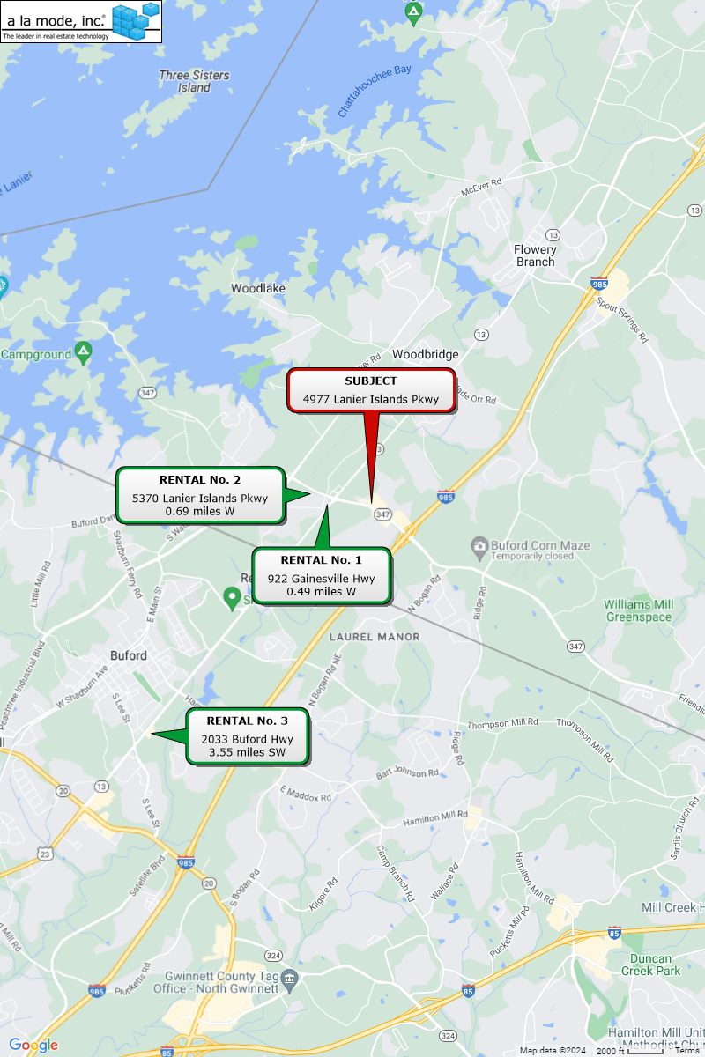

**Analysis and Discussion of Lease Comparables**

The leases have been analyzed and compared with the subject property. Adjustments are discussed in the summary below and shown in the rent comparison adjustment grid that follows.





**Market Rent Conclusion - Office**

After adjustments, the lease comparables ranged from $16.36/sq. ft. to $20.50/sq. ft., with an average of $18.81/sq. ft. Overall, the leases are considered comparable due to their improvement characteristics and their locations. Comps 1 and 2 are considered to be the most similar due to their proximity to the subject and overall similarity. The subject’s in-place office units average $15.58/sq. ft. with a range of $12.48/sq. ft. to $18.48/sq. ft.

After considering all value factors with respect to location, quality of interior improvements, building characteristics and market demand, the market rental rate that the subject could feasibly achieve is concluded to be **$17.00/sq. ft.** on a triple net basis.

***RETAIL***

 **RENT COMPARABLE MAP**

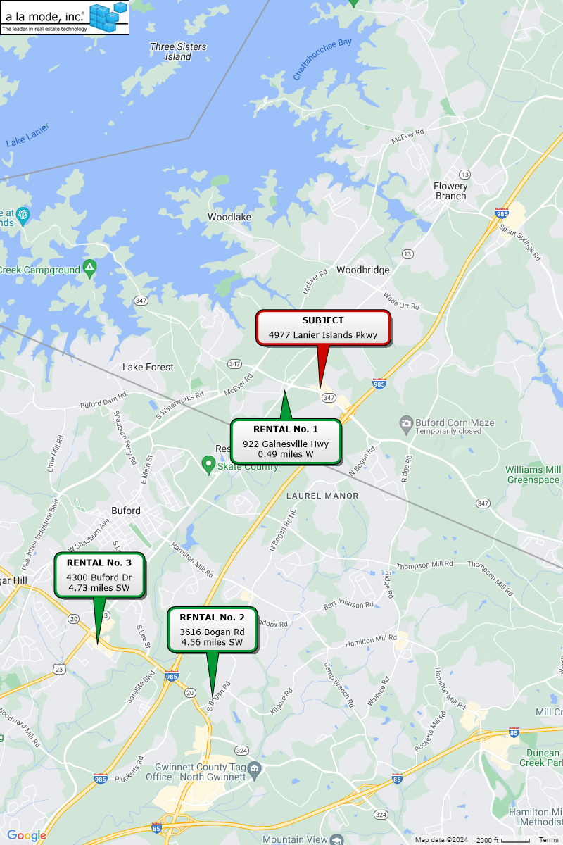

**Analysis and Discussion of Lease Comparables**

The leases have been analyzed and compared with the subject property. Adjustments are discussed in the summary below and shown in the rent comparison adjustment grid that follows.





**Market Rent Conclusion – Retail**

After adjustments, the lease comparables ranged from $15.00/sq. ft. to $16.44/sq. ft., with an average of $15.92/sq. ft. Overall, the leases are considered comparable due to their improvement characteristics and their location. All comparables were considered in the conclusion analysis given the low adjustments ranging from 0% to 5%, however Comp 1 was given primary emphasis due to its overall similarity and proximity to the subject. The subject’s in-place retail units average $15.38/sq. ft. with a range of $12.73/sq. ft. to $21.92/sq. ft.

After considering all value factors with respect to location, quality of interior improvements, building characteristics and market demand, the market rental rate that the subject could feasibly achieve is concluded to be **$16.00/sq. ft.** on a triple net basis.

**POTENTIAL GROSS INCOME**

The following table summarizes the potential gross rent based on the market rents. Unit 110 received a slightly higher rent due to the smaller unit size and Unit 104-105 received a slightly lower rent to the larger size.



**VACANCY AND COLLECTION LOSS**

This category accounts for vacancy as well as the time between occupants (frictional vacancy). This occupancy may vary from period to period. However, a typical investor would utilize this stabilized occupancy level within a pro forma operating statement. A provision for collection loss is typically factored in this ratio.

As seen in the marketability analysis found earlier in this report, the vacancy rate for office properties within the Gainesville Hall County submarket (which includes the Buford area) are currently averaging 4.3% and for retail properties within the Gainesville Hall County submarket are currently averaging 2.0% (for strip retail).

Additional analysis of all retail/office properties within a five-mile radius of the subject yielded 18 buildings with an average size of 18,214+/- sq. ft. The current average vacancy rate was 9.0%, with a five-year average vacancy rate of 8.95%.

Further, upon discussions with local leasing agents and an inspection of the market and the sales comparables, the local vacancy rate for retail properties appears to be between 8% and 10%.

The market analysis also shows that the market is generally stable. Thus, an **8% vacancy** or 92% occupancy and collection loss ratio is considered reasonable for the subject property during the economic life of the current improvements.

**OPERATING EXPENSES**

To develop projections of stabilized operating expenses, we analyze the subject’s expenses, comparable data, and industry benchmarks. The following table details the subject’s current expenses and recent history. As appropriate, the owner’s operating expenses are reclassified into standard categories and exclude items that do not reflect normal operating expenses for this type of property.



**Other Income**

Historical other income at the subject consists of rent concessions, miscellaneous income, and late charges. In 2023, this figure totaled $1,727. For underwriting purposes, a $1,500 figure was carried forward to the Proforma.

**Expense Reimbursements**

Based on the reimbursements as shown in the subject historical data, a reimbursement of $167,700 has been incorporated into the direct capitalization model. As previously noted, all of the leases at the subject are leased on a NNN basis with the tenants being responsible for management fees, real estate tax expense, insurance, repairs and maintenance, CAM, and utilities. This will be presented in the Income Approach.

**EXPENSE DISCUSSSION**

**Real Estate Taxes**

The subject property is taxed by Hall County based on an assessment made by the Hall County Tax Assessor. Details of the subject’s real estate taxes are discussed in the *Real Estate Tax* section of this report. This expense has been estimated at $87,000. The tax figure was derived using the concluded market value with a 40% assessment ratio and the current millage rate. Due to the leasing structure, this expense will be passed through to the tenants.

**Insurance**

The appraisers reviewed the operating statements of several office buildings in the Hall County area and expenses reported by CoStar. According to CoStar and the office market in Buford, over the last three years, the insurance expenses for office buildings have ranged from $0.30/sq. ft. to $0.70/sq. ft. Therefore, after considering the foregoing, the subject has a projected annual premium of $11,000 ($0.47/sq. ft), in line with the historical expense. Due to the leasing structure, this expense will be passed through to the tenants.

**Management Fee**

The subject property has an estimated management expense of approximately 4% of effective gross income. This estimated percentage is reasonable considering comparable buildings are usually managed for fees ranging from 2% to 7%. The higher fees are typically charged for large multi-tenant buildings. After considering the characteristics of the subject property, the subject’s estimated management fee of being 4% of effective gross income is considered reasonable and appropriate. Due to the leasing structure, this expense will be passed through to the tenants.

**Utilities**

This expense consists of utility costs for the units. This expense was estimated at 1.5% of effective gross income, which is in-line with market averages, as well as subject historical utility expense data. Due to the leasing structure, this expense will be passed through to the tenants.

**Miscellaneous**

This expense includes miscellaneous expenses such as consulting expenses, miscellaneous insurance, office supplies, audit fees, subscriptions, etc., and serves as a catch all category for items not generally covered by the other expense categories. The subject is estimated to have a general administrative expense of 0.6% of effective gross income, in-line with the subject historical expense data. The landlord is responsible for this expense.

**CAM**

CAM expenses covers lawn maintenance, keeping the parking area clean, and applicable lawn care. Since the tenants are leased on a NNN basis, this category also includes repairs and maintenance expenses. Considering the land and large parking area, location, and physical characteristics of the subject, the annual CAM expense is estimated at $1.79/SF, in-line with subject historical expense data. Due to the leasing structure, this expense will be passed through to the tenants.

**Reserves**

Reserves cover expenses for short lived and long-term items that wear out over time, such as: water heater, roof, painting, and fixtures. The subject was built in 2007, has been well maintained, and is considered to be in good condition. This expense was estimated at $0.20 per sq. ft. or 0.9% of effective gross income.

**CAPITALIZATION RATE**

The capitalization rate is the factor that converts the stabilized net operating income (NOI) to a present value. It is the ratio of net income to value or sale price. In coming to an appropriate overall capitalization rate conclusion, the appraisers utilized recent market surveys from various sources, a review of Keystone appraisal files, (if available) capitalization rates derived from sales data, as well as discussions with real estate professionals from within the subject market and other competitive markets.

**Sales Comparison Approach**

The preceding Sales Comparison Approach provided only one capitalization rate in Sale 1 at 7.30%. The rest of the comparables did not have disclosed rates.

A capitalization rate survey conducted on retail properties within the immediate surrounding areas of the subject over the last three years in properties between 10,000 SF and 40,000 SF, a rate range of 6.03% to 7.50% was yielded. The overall median was 6.95%.

**RealtyRates.com**

According to 4Q 2023 Realty Rates Investor Survey, for suburban office buildings, the capitalization rates ranged from 6.24% to 12.84% with an average of 8.83% for surveyed rates.

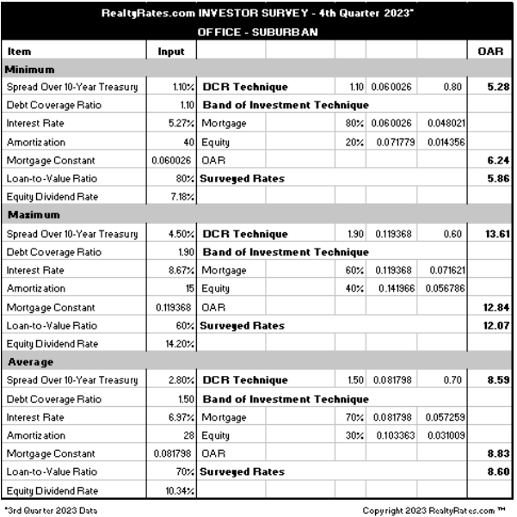

According to 4Q 2023 Realty Rates Investor Survey, for unanchored retail buildings, the capitalization rates ranged from 6.24% to 12.84% with an average of 8.83% for surveyed rates.

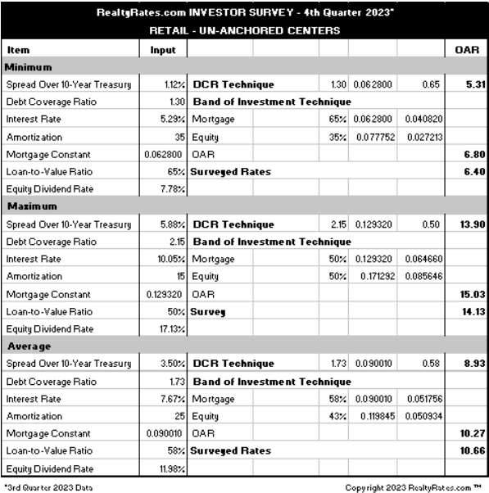

**PwC Survey**

According to the 4Q 2023 PwC Real Estate Investor Survey, capitalization rates ranged from 5.25% to 10.00% with an average of 7.50% for the National Strip Shopping Center market. Considering current national economic conditions, local market conditions, the subject's size, and tenant finish, a cap rate in the low to middle range of those surveyed is considered appropriate.

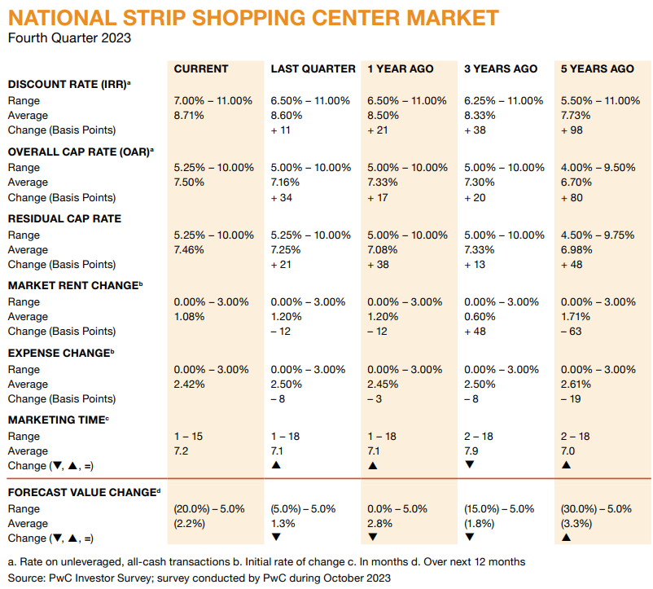

**Market Participant Interviews**

Multiple interviews were conducted with market participants familiar with retail space, particularly in Hall County. Market Participants have indicated that depending on quality of the building, location, visibility, and tenant quality, capitalization rates range between the high 6%’s to the mid-level 7%’s. Local expertise individuals including Coldwell Banker (Reha Guven) and private property owners in the local area were contacted to confirm local market data.

**Capitalization Rate Conclusion**

Upon consideration of the various supportive data sources, as well as the subject’s location, building age, quality of improvements, local market conditions, an overall capitalization rate of **7.00%** is selected for the Income Approach.

**DIRECT CAPITALIZATION CONCLUSION**

Based on the previous analysis, the direct capitalization approach has been reconciled in the following chart.



**LEASE UP COSTS (RENT LOSS)**

When a property has a below market income stream due to high vacancy and/or below market rents, an adjustment to value is often necessary for lost income over the lease-up period, leasing commissions associated with lease-up and perhaps tenant fit-up and additional operating expenses associated with the vacant space over the lease-up period. The table below details the stabilization calculations for the subject.

There are currently two spaces that are vacant with concluded market rental rates of $16.00/SF and $17.00/SF (different due to the size differences of the units). Both spaces were leased up utilizing three-year lease terms with an estimated ten-month lease-up timeframe. Tenant improvements were assumed at $15.00/SF. Free rent was estimated at ten months for both units due to local market averages and discussions with the property manager.



**FINAL VALUE RECONCILIATION**

The process of reconciliation involves the analysis of each approach to value. The quality of data applied the significance of each approach as it relates to market behavior and the defensibility of each approach are considered and weighed. Finally, each is considered separately and comparatively with each other.



**Cost Approach**

The cost approach is most reliable for newer properties that have no significant amount of accrued depreciation. Due to the age of the subject improvements, estimates of depreciation are subjective, limiting the reliability of this approach. Additionally, the cost approach is not typically used by market participants, except for new properties. As previously discussed, the Cost Approach is judged to be inapplicable and is not utilized.

**Sales Comparison Approach**

The sales comparison approach is most reliable in an active market when an adequate quantity and quality of comparable sales data are available. In addition, it is typically the most relevant method for owner-user properties, because it directly considers the prices of alternative properties with similar utility for which potential buyers would be competing.

The analysis and adjustment of the sales provides a reasonably narrow range of value indications. Nonetheless, it does not directly account for the income characteristics of the subject. Therefore, this approach is given secondary weight.

**Income Approach**

The income capitalization approach is usually given greatest weight when evaluating investment properties. The value indication from the income capitalization approach is supported by market data regarding income, expenses and required rates of return.

An investor is the most likely purchaser of the appraised property, and a typical investor would place greatest reliance on the income capitalization approach. For these reasons, the income capitalization approach is given greatest weight in the conclusion of value.

**Value Conclusion**

It is our opinion that the Market Value in the Leased Fee Estate, of the 23,450 sq. ft. retail building, *“As Is”* located at 4977 Lanier Islands Pkwy, Buford, Hall County, Georgia, as of February 23, 2024, is:

|  |
| --- |
| **FOUR MILLION SIX HUNDRED THOUSAND DOLLARS**  **($4,600,000)** |

**MARKETING PERIOD AND EXPOSURE TIME**

**Marketing Period**

The *marketing time* is an opinion of the amount of time it might take to sell a real or personal property interest at the concluded market value level during the period immediately after the effective date of an appraisal. Marketing time differs from exposure time, which is always presumed to precede the effective date of an appraisal. (Advisory Opinion 7 of the Appraisal Standards Board of The Appraisal Foundation and Statement on Appraisal Standards No. 6, “Reasonable Exposure Time in Real Property and Personal Property Market Value Opinions” address the determination of reasonable exposure and marketing time.)

There are no anticipated significant changes in market conditions in the near term. Thus, it is our opinion that a reasonable marketing period for the subject is likely to be 6 to 12 months.

**Exposure Time**

The *exposure time* is the time period assumed to have occurred prior to the date of the appraisal as required in the definition of the market value.

1. The time a property remains on the market. \
2. The estimated length of time the property interest being appraised would have been offered on the market prior to the hypothetical consummation of a sale at market value on the effective date of the appraisal; a retrospective estimate based on an analysis of past events assuming a competitive and open market.

Based on our review of recent sales transactions for similar properties and our analysis of supply and demand in the local market, it is our opinion that the probable exposure time for the subject at the concluded market value / values stated previously is 6 to 12 months.

**EXHIBIT I**

**ENGAGEMENT LETTER**

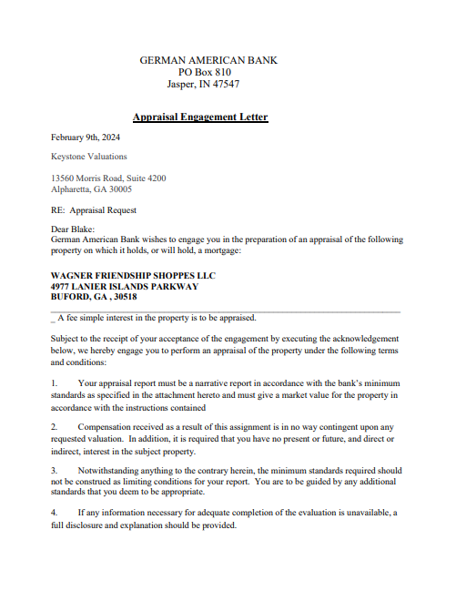

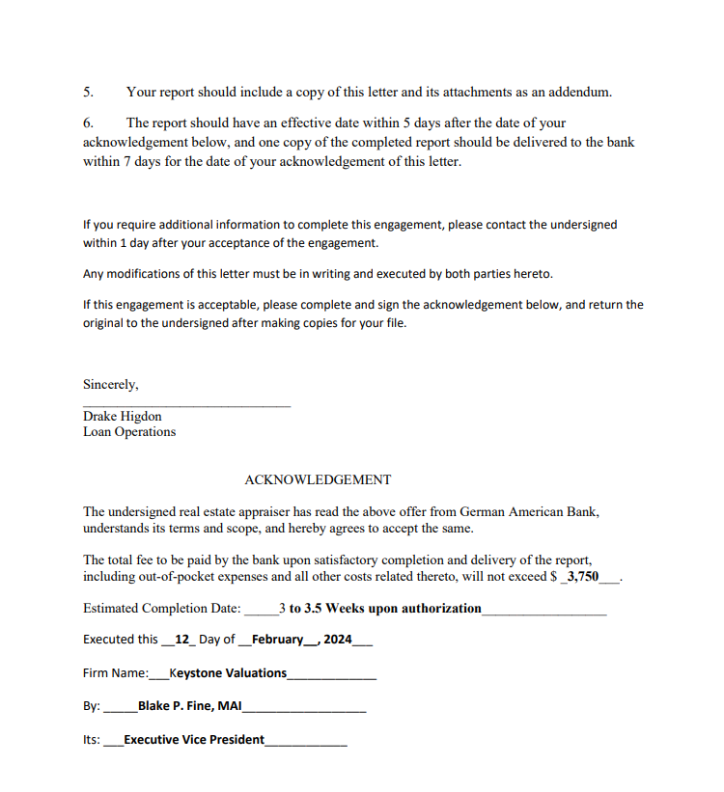

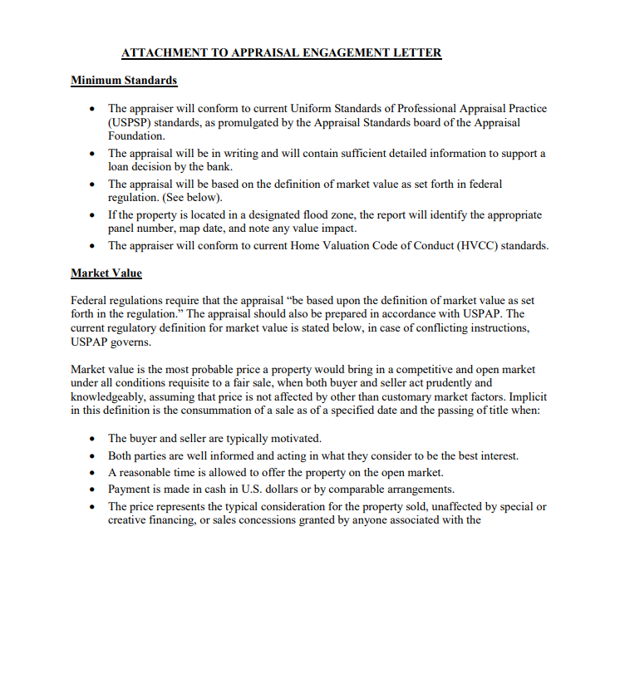

**EXHIBIT II**

**PROFESSIONAL QUALIFICATIONS**

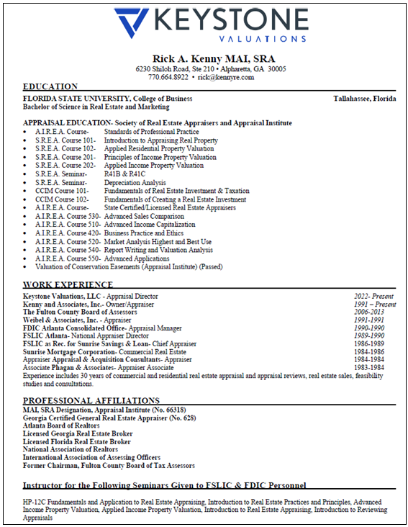





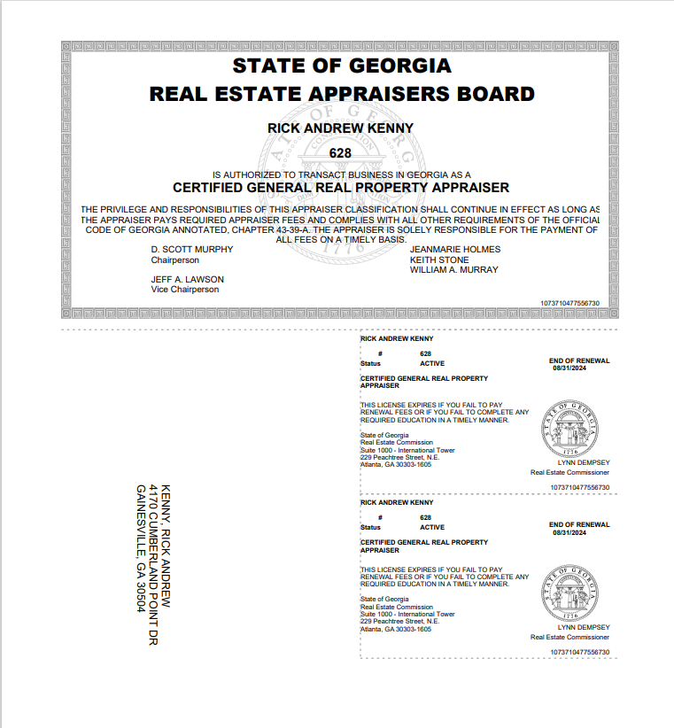



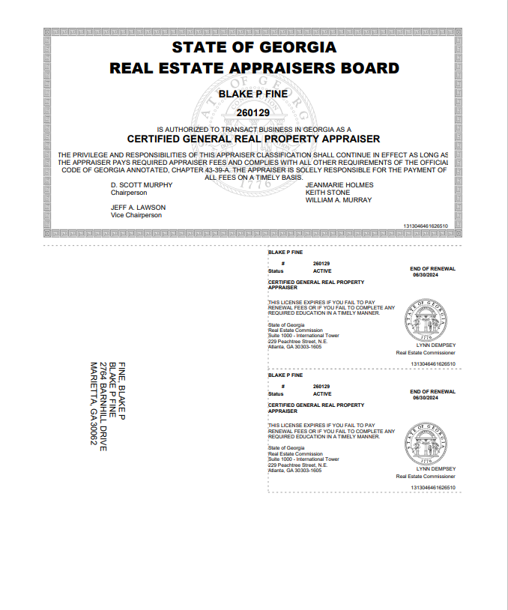

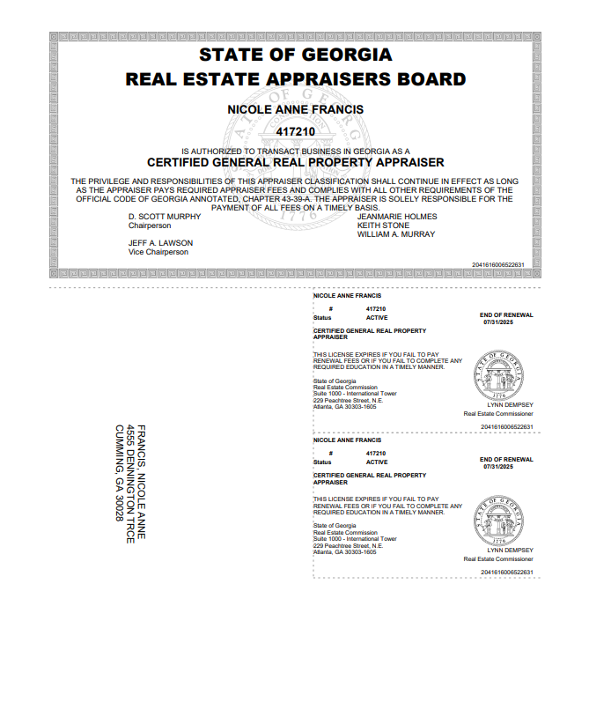

1. *The Appraisal Institute*, *Market Analysis for Real Estate*
2. *Appraisal Institute Market Analysis and Highest and Best Use*
3. *Appraisal Institute Market Analysis and Highest and Best Use*
4. *The Dictionary of Real Estate*, Sixth Edition, page 144